**Empowering Village Voices: Mapping the Social Network of Villagers in India that influences their Political Participation**

*By Nishita Karun & Harsh Vardhan Pachisia*

May 2024

We are doing the research paper option, number 1. Harsh conducted data collection, cleaning, and analysis. We both worked on methodology. Nishita focused on literature review and discussion. We both wrote up different sections.

**Abstract**

This paper explores the intricate dynamics of social networks and their influence on political participation in rural India. Through a detailed analysis of village-level social networks in Maharashtra and Kerala, the study aims to identify how social capital—rooted in caste, religion, and institutional affiliations—affects political engagement. Using the India Human Development Survey (IHDS) data, we constructed networks to map household connections to various formal institutions, such as cooperatives, self-help groups, and public meetings. The findings reveal significant disparities in network structures and centrality measures between the two villages, highlighting the crucial role of social integration and community institutions in fostering civic participation. In the village in Maharashtra, the network exhibited lower density and fewer active institutions, indicating limited community engagement, with centrality measures pointing to a concentration of influence among specific caste groups. In contrast, Kerala's village displayed a more interconnected and denser network, with public meeting groups serving as central hubs for community interaction. This higher level of integration was associated with increased political participation, particularly among diverse social groups. The study underscores the importance of enhancing network density and inclusivity to improve civic engagement and ensure equitable political representation in rural India.

**Introduction**

Voting behavior is a complex phenomenon influenced by various factors that shape the decision-making process of voters. In the context of India, a vibrant democracy with diverse socio-cultural, economic, and political dynamics, understanding the factors that influence voter choice is crucial to build true representation. In rural India, which is heavily governed by welfare schemes, it is even more important to have the correct policies through a voice in politics and have enough influence to receive timely and no-cost welfare. The reality today is very different as social influence plays a role in receiving welfare and makes political participation even more key for rural development. This paper aims to delve into the key determinants of voting behavior like identity - caste, religion and gender, and access to government (elected and appointed) in India to identify how social networks play a role in shaping political participation. Through a detailed analysis of village-level social networks, we aim to examine the interaction between social capital and political engagement. We also provide insights into the mechanisms through which social structures impact democratic processes.

Political participation in India has undergone significant changes over the decades, influenced by socio-economic developments, shifts in political landscapes, and the advent of digital technologies. Historically, the early years following independence saw high voter turnout, driven by a sense of national pride and the novelty of democratic processes. However, traditional social structures such as caste and community leaders often dictated voting patterns. From the 1970s to the 1990s, political participation evolved with the emergence of new political movements and parties, notably the rise of regional parties advocating for the rights of marginalized communities, such as Dalits and Other Backward Classes (OBCs). The liberalization of the Indian economy in the early 1990s brought new dimensions to political participation, with economic reforms leading to the rise of a burgeoning middle class that began to assert its influence in politics. This period also saw an increase in issue-based politics, with economic policies and corruption becoming central electoral issues. The 1990s also marked the rise of the Bhartiya Janata Party (BJP), which utilized a blend of economic policies and cultural nationalism to mobilize voters.

India's caste system has a deep-rooted impact on voting patterns. Voters often align with political parties that cater to their caste interests, leading to caste-based voting blocs and consolidation. The National Election Study (NES) conducted after the 2014 Lok Sabha elections found that caste considerations influenced voting decisions for around 33% of voters in India. This trend is particularly prominent in states like Uttar Pradesh, Maharashtra, Haryana, and Bihar. Caste remains a significant determinant, with voters often supporting candidates from their own caste groups or those who promise caste-based benefits. For example, the Bahujan Samaj Party (BSP) has garnered substantial support from Dalits by emphasizing their upliftment. Similarly, the political success of parties like the Rastriya Janata Dal (RJD) in Bihar can be attributed to their appeal to Yadav and other backward classes. Religion also plays a crucial role, as evidenced by the Bhartiya Janata Party's (BJP) strategy of consolidating Hindu votes through its promotion of Hindutva ideology, which has been instrumental in its electoral victories. The Pew Research Center's study on religion and public life found that religion played a role in voting decisions for 64% of Indian adults. Prior to 2019, Muslim voting behavior was significantly fragmented, and there were no clear signs of constituency-level coordination behind a single political party. Notably, however, voting behavior has become more complex since the BJP’s 2019 victory. Regional parties like the Trinamool Congress (TMC) in West Bengal and the Telugu Desam Party (TDP) in Andhra Pradesh highlight the importance of regional identity.

In recent years, the digital era has revolutionized how citizens interact with government bodies, particularly at the grassroots level in India. Digital platforms have democratized political engagement, allowing citizens to participate in political discourse beyond traditional rallies and voting. Social media campaigns and digital mobilization have played crucial roles in the electoral successes of parties like the AAP and BJP. Research indicates that social media has become a vital tool for political mobilization, especially among the youth and urban populations (Chauchard, 2018). Additionally, voter turnout has increased, particularly among women and first-time voters, indicating a broadening of the electorate. Overall, there is a movement towards broader issues, but in majority rural India we still see voting on the basis of identity and access to government. We will use this social network analysis as a foundation to develop this hypothesis and accordingly build programs which could improve this decision making process by improving the interaction between citizens and governments.

**Literature Review**

The literature reviewed provides a comprehensive understanding of how social networks, political connections, and digital platforms influence political participation and economic outcomes in India.

Research on social networks and political participation in India reveals significant insights into how social structures influence civic engagement. Misra et al. (2014) proposed using Social Network Analysis (SNA) to study the complexity of rural livelihoods and the role of institutions. Their research aimed to identify influential actors and key institutions within livelihood systems, providing insights that could help rural development administrators deliver services more efficiently. This approach highlights the importance of analyzing social networks to understand and improve rural livelihoods. Khan (2020) analyzed the role of village and household characteristics in obtaining the Rastriya Swasthya Bima Yojana (RSBY) health insurance scheme card in India. The study found that households with membership in caste associations and attendance at public meetings were more likely to enroll in the RSBY scheme, highlighting the role of political connections and public good activism in accessing government programs. Kumar et al. (2018) focused on women's self-help groups (SHGs), finding that SHG members were more politically engaged and had greater awareness and use of government entitlement schemes compared to non-members. These groups provided a platform for women to expand their social networks, thereby enhancing their political participation and ability to hold public entities accountable. The study emphasizes the importance of deliberate efforts by external agencies to enhance awareness about public entitlements through these networks. Johny et al. (2017) investigated the influence of social networks on income diversification in rural India. Their study found a significant positive network effect, indicating that households with more social connections diversify their income sources more effectively. Network centrality was also found to have a positive impact on diversification, suggesting that households in prominent network positions have greater access to resources and information.

The impact of social networks on economic outcomes has also been explored in the context of education and earnings. Hussain and Mukhopadhyay (2020) found that education significantly and positively affects earnings across various demographics in India. Social networking positively impacts earnings for males, Hindus, and certain economic quintiles. Similarly, Bhattacharjee and Mohanty (2020) examine the link between social networks and out-of-pocket health care expenditure (OOPE). They found that social networks facilitate information dissemination, reducing healthcare costs by increasing the use of public welfare programs. Emerging literature suggests that the identity of a politician significantly influences the exercise of political authority.

Evidence indicates that political reservation can also affect policy outcomes. For instance, Besley et al. (2007) highlight that Gram Panchayats (GPs) reserved for women exhibit higher investment in infrastructure projects such as road construction, drinking water facilities, and recycled fuel equipment, compared to unreserved GPs where investment in education is more prominent. Chattopadhyay and Duflo (2004) further demonstrate that reserved GPs also show better monitoring of health workers, emphasizing the positive impact of political reservation on public goods provision. The concept of "Madisonian presumption in favor of greater capture at the local level," where well-connected interest groups benefit from higher levels of voter ignorance, is supported by Bardhan and Mookherjee (2000). In India, caste plays a crucial role in this dynamic. Upper castes, with their higher representation in government, have been able to capture government resources. Panda (2015) found a strong positive association between political connections and the procurement of Below Poverty Line (BPL) cards. Politically connected households are more likely to obtain BPL cards than politically unconnected ones. Alatas et al. (2013) also found that elites with formal leadership positions are more likely to obtain welfare benefits compared to informal leaders. Gambhir, Desai, and Vanneman (2017) noted that households attending political meetings are positively associated with obtaining Ration Cards (RCs), whereas local governance membership shows an inverse relationship.

Vafaeva et al. (2024) studied how digital social networks and community involvement interact to foster community engagement and sustainable urban growth in Smart Cities in India. Using data from demographics, community participation programs, and digital social networks, they conducted a Social Network Analysis (SNA) to examine the size, density, and centrality of digital social networks. Their findings underscore the effectiveness of integrating various data sources to assess community engagement initiatives.

**Research Question & Hypothesis**

We will conduct this study along the research question, **how do socio-demographic factors and informal social networks influence political participation through institutional memberships in rural settings?**

This question is motivated by the hypothesis that access to influential village groups which define identity and members of government improves political participation as it instills a deeper trust in the system. The role of formal and informal association with “accompanying norms of generalized trust and reciprocity” is a critical dimension of social capital. Social capital has played a very substantial role in the effectiveness of society at socio-economic and political level. A group or society with high social capital is likely to perform better than a group with less social capital. This is because “social capital allows people to overcome collective action problems more effectively and at lower cost,” this in turn results in improved performance (Coffé, & Geys, 2005). A network data collection approach is critical over a traditional approach since our goal is to understand the structural patterns of how people in the village connect with member organizations and map on characteristics like connection with political leaders.

**Dataset**

For this study, finding data was a particularly difficult task given the sparsity of available network data in India. As a result, we had to construct a network dataset using a survey dataset. We use survey data from the India Human Development Survey (IHDS). In particular, we use IHDS II, conducted in 2011-12. This data set emerged as a collaborative research program between the National Council of Applied Economic Research, New Delhi, India, and the University of Maryland, United States (Desai & Vanneman, 2005, 2015). Certain features of the IHDS data set make it unique in comparison to the commonly used data sets in Indian literature. First, topics in IHDS extend across indicators of caste, community, consumption, the standard of living, energy use, income, agriculture, employment, government subsidies, education, social and cultural capital, household and family structure, marriage, gender relations, fertility, health, village, infrastructure, among others. Second, the human development indicators documented are extensive and the data set contains a wide array of contextual measures. IHDS II covers 42,152 households in 384 districts, 1,420 villages, and 1,042 urban blocks located in 276 towns and cities. It covers all states and union territories of India except Andaman/Nicobar and Lakshadweep.

**Methodology**

Since the survey does not contain individual names of connections, we cannot do a direct social network analysis. However, it does ask each household whether they are members of certain community/political groups as well as whether they know politicians, government officials and police. Due to this and after extensive literature review, we realized that we should map households' connections to various formal institutions (e.g., cooperatives, caste or religious groups, self-help groups) and analyze how these connections are affected by characteristics such as caste and religion.

*Construction of villages dataset*

The initial step in our network analysis involves the meticulous selection of two villages from the village level dataset ("00012") which consists of various villages, each potentially unique in its demographic and social composition. The chosen village must contain a representative range of membership groups that are integral to gauging political participation within the community. This selection is critical as it ensures that the subsequent analysis reflects the true dynamics and interactions of different societal segments influencing political processes. With this in mind, we only filtered to villages in the dataset that had at least 15 out of 16 institutions, giving us 14 villages to choose from. We chose two villages from this list, based on their caste and religion and the number of households present. We valued more diversity in caste and religion since that would allow us to understand the differences in political participation later on.

**With these criteria, we selected two villages, one in the Western state of Maharashtra and the other in the Southern state of Kerala. We describe the two villages and their demographic composition below.**

Maharashtra Village

Budhwana District (96 Villages) is located in the Amravati division of Maharashtra, India. It is situated at the western border of Vidarbha region and is 500 km away from the state capital, Mumbai. According to the 2011 census Buldhana district has a population of 2,586,258, roughly equal to the US state of Nevada. The district contributes one seat to the Lok Sabha (Lower House), namely Buldhana (Lok Sabha constituency). Prataprao Ganpatrao Jadhav of Shiv Sena is the current Member of Parliament from Buldhana. The district has seven seats in the Maharashtra State legislature assembly: Buldhana, Chikhli, Sindkhed Raja, Mehkar, Khamgaon, and Jalgaon Jamod. The seventh seat at Malkapur is part of Raver (Lok Sabha constituency) in Jalgaon district. Buldhana has a sex ratio of 928 females for every 1000 males, and a literacy rate of 82.09%. 21.22% of the population lives in urban areas. Scheduled Castes and Scheduled Tribes make up 18.21% and 4.39% of the population respectively. Population Density - 268 / sq.km. In the village analyzed, we see a mix of religions and caste, as showcased in the figures below.

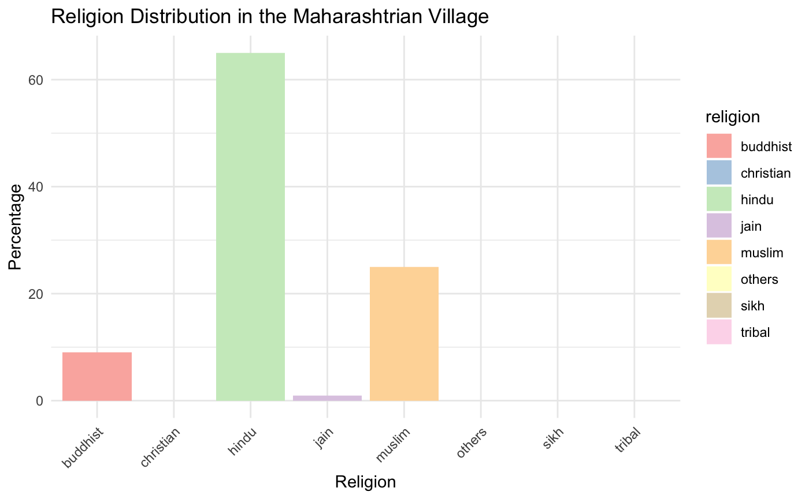

**Figure 1**

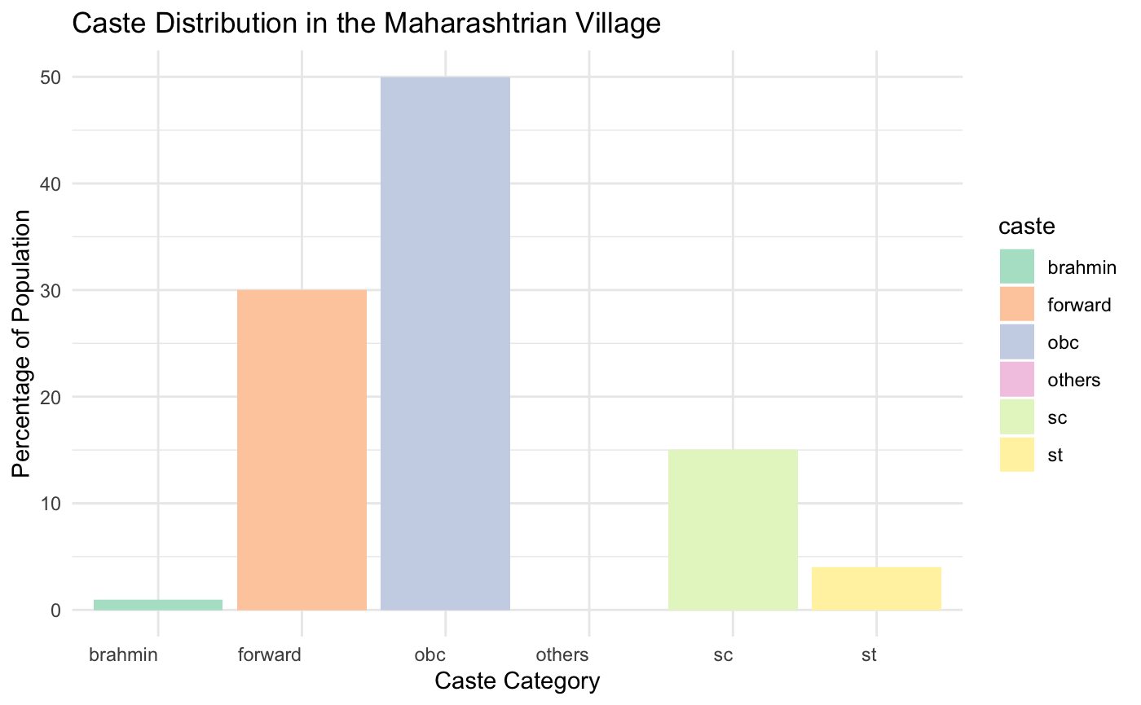

**Figure 2**

As we can see, there is a mix of religions (Figure 1) in this village, with Hindu being dominant (65%), but 25% Muslims, and 9% Buddhist and 1% Jain. In terms of caste, Other backward (Figure 2) castes (OBC) are dominant with 50%, with forward and brahmin castes around 31-32% and scheduled castes and scheduled tribes make up the remaining share.

The district has a voter participation rate of 53.29% in the 2024 Lok Sabha election (lower than the national average of India) and the selected village has a male elected Panchayat leader (Pradhan), appointed Panchayat secretary and elected region MLA from an OBC (other backward caste) and SC (Schedule Caste) and Hindu.

Kerala Village

According to the 2011 census, Alappuzha district has a population of 2,127,789 roughly equal to the US state of New Mexico. The district has a population density of 1,504 inhabitants per square kilometer (3,900/sq mi) . Its population growth rate over the decade 2001–2011 was 0.88%. It has a sex ratio of 1100 females for every 1000 males, and a literacy rate of 95.72%. 53.96% of the population lives in urban areas. It has the highest population density among all districts of the state. It is 29.46% urbanized and is the smallest district in Kerala.

In the village analyzed, we see a mix of religions and caste, as showcased in the figures below.

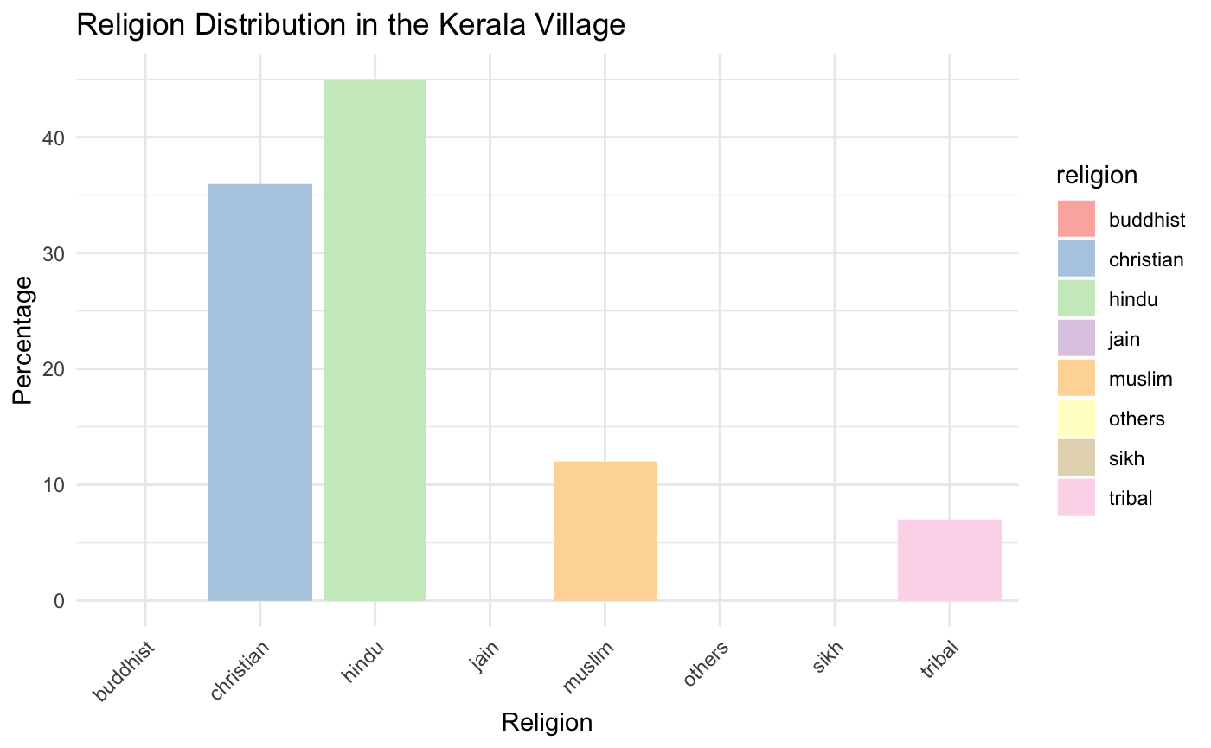

**Figure 3**

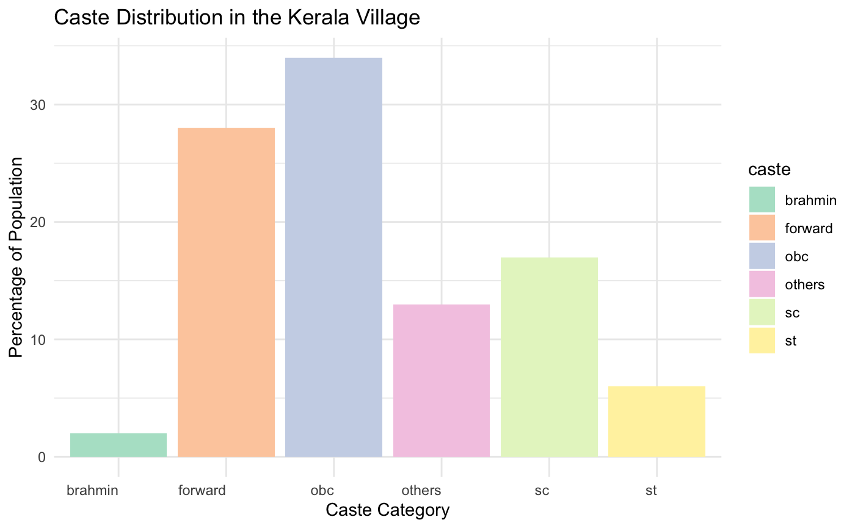

**Figure 4**

In the Kerala village, given its geographical location, we see a different set of villages in Figure 3 with 50% Hindus but also 35% Christians with Muslims and tribal communities making up the rest of the households. In terms of caste in Figure 4, again OBCs dominate with over 35%, but forward and brahmin castes also make up close to 28% of the population. Scheduled Castes and Scheduled Tribes make up 9.46% and 0.31% of the population respectively.

The district has a voter participation rate of 75.05% in the 2024 Lok Sabha election (higher than the national average of India) and the selected village has a male elected Panchayat leader (Pradhan), appointed Panchayat secretary and elected region MLA from an upper caste and Christianity.

*Construction of household-level dataset*

Once suitable villages are identified, focusing on the diversity and inclusivity of groups, we proceed to extract specific variables from dataset "002”, which contains household level information. In particular, this dataset details individual and group memberships (ME variables) which signify the institutional affiliations of the households. These variables were binary (1 if the household is a member of the institution, 0 if not). Additionally, it includes variables related to social networks (SN variables), which are crucial for understanding indirect interactions and their impact on political participation. These include binary variables on whether the household knew any government officials, policemen or politicians. These extractions are aimed at capturing a comprehensive view of the formal and informal networks that underlie the political landscape of the village. We also obtained the religion and caste of each household.

*Construction of networks*

After we created the household level dataset with the required variables for each village, we then moved to constructing the network for each village. This starts with two distinct sets of nodes: households and institutions or groups. These nodes are central to understanding the structure of interactions within the village. Households represent the fundamental social units, while institutions embody the formal and informal groups that mediate political and social activities. Edges between these nodes are established based on the actual memberships recorded, illustrating the direct linkages between households and various institutions. To add depth to the analysis, node attributes for households are enriched with sociocultural markers such as caste and religion, alongside other political indicators like links to influential people. Given that there were multiple variables for these, we decided to club them into three buckets: links to the police, politicians, or government officials and added them as household node characteristics. This granularity allows for a nuanced exploration of how these attributes influence both the network structure and the intensity of political engagement in the village. This network model aims not only to map out the visible structures but also to unearth the underlying forces that shape political participation in rural settings.

To create the network, we built out an edge list with the connections between the households and the institutions, with the other social network and demographic characteristics serving as node attributes for households. Even if households were not connected to any institutions (degree of 0), we kept them in the network since those households highlighted total lack of connectivity to any sort of political participation. We then added the attributes of caste, religion and links to government, politicians, and police to each of the nodes to get final graphs for both the village in Maharashtra and the village in Kerala.

**Findings**

**Maharashtra village**

Descriptive statistics and centrality measures

The Maharashtra village had 35 nodes (31 households and 4 institutions). Despite the village having 15 institutions of the households that were interviewed, only 4 institutions are present. These included groups on religion, caste, a self-help group (tailored to doing business) and a public meeting group (tailored to governance issues). It also had 50 edges with the largest component size of 26 with the other household nodes being completely disconnected from the institutions. We still chose to include these since they highlight a complete lack of connectivity to any sort of political participation. The density of the village is low at 8%, highlighting that not a lot of households are members of every institution.

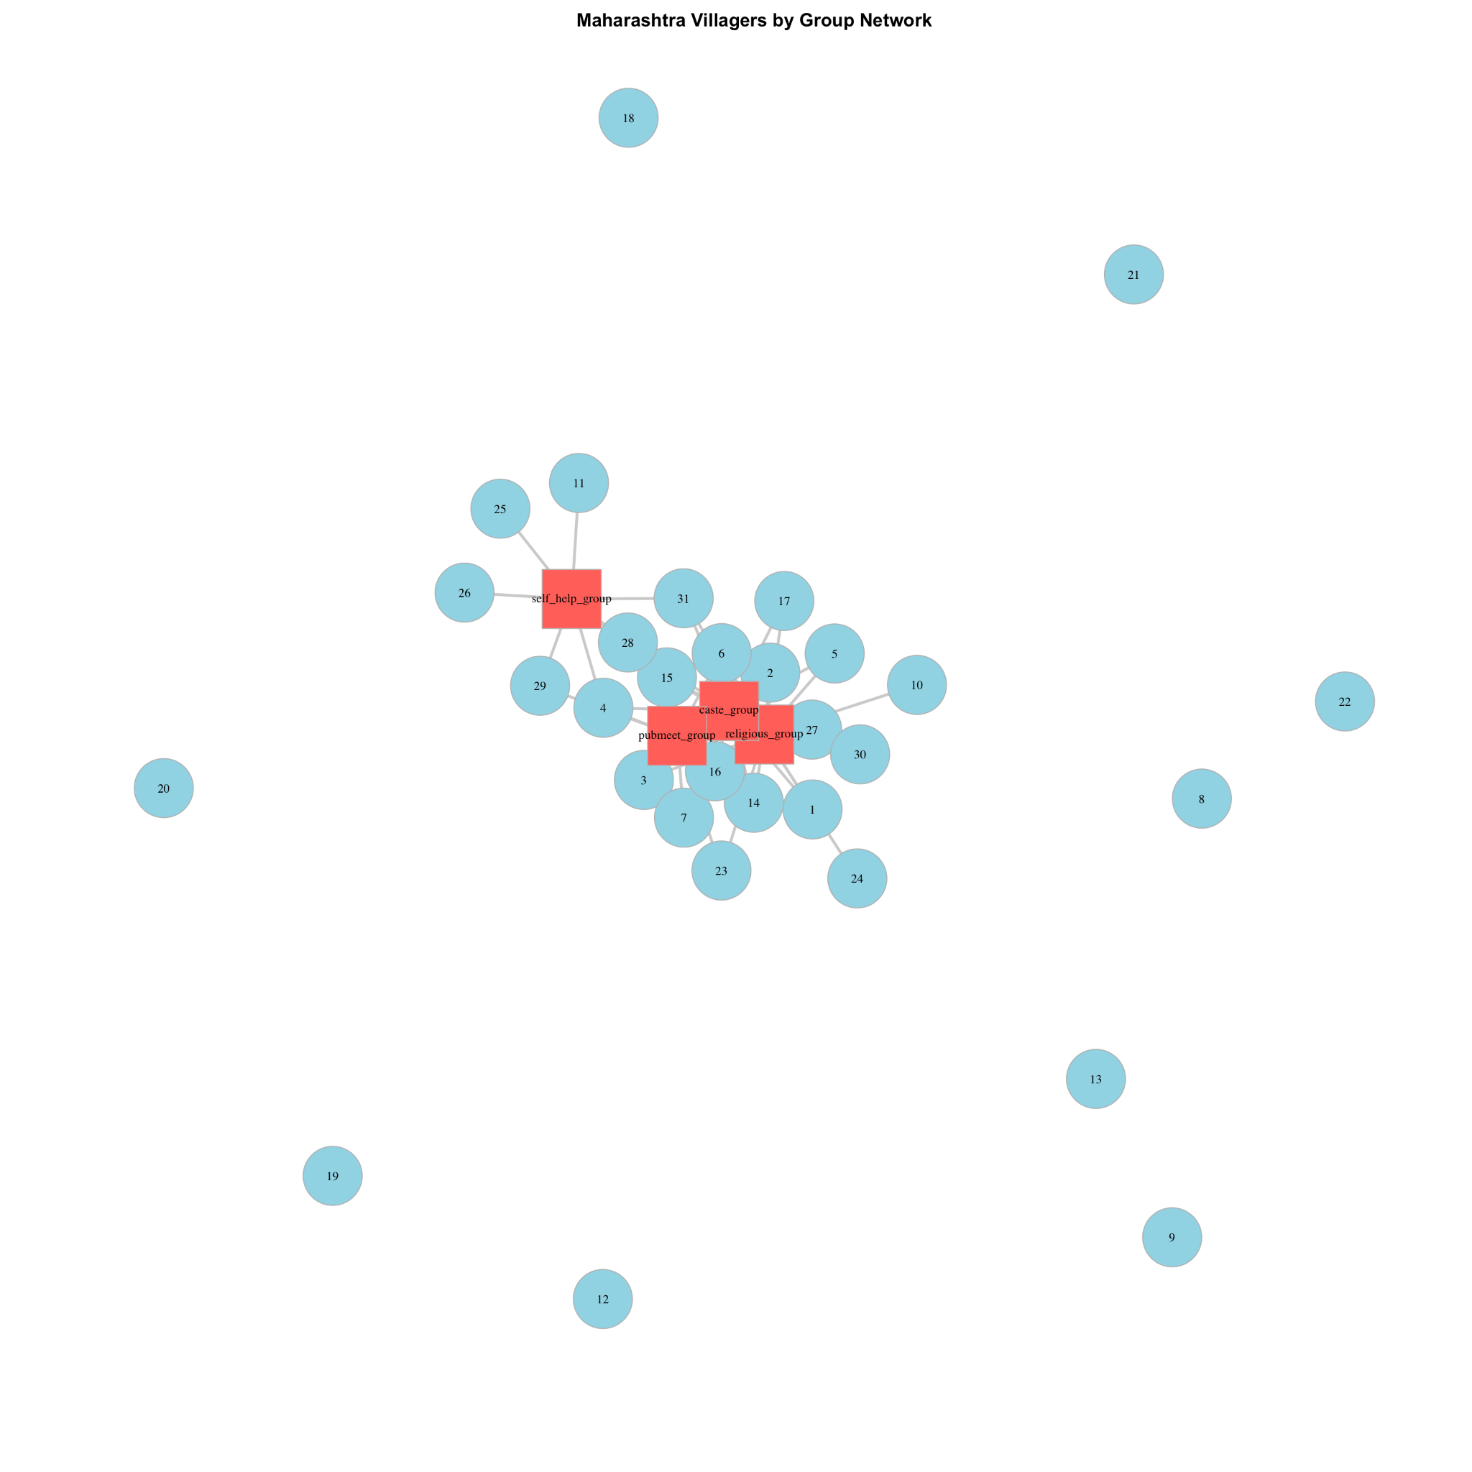

**Figure 5**

We then calculated the various centrality measures, namely degree, betweenness, closeness and eigenvector centrality as showcased below.

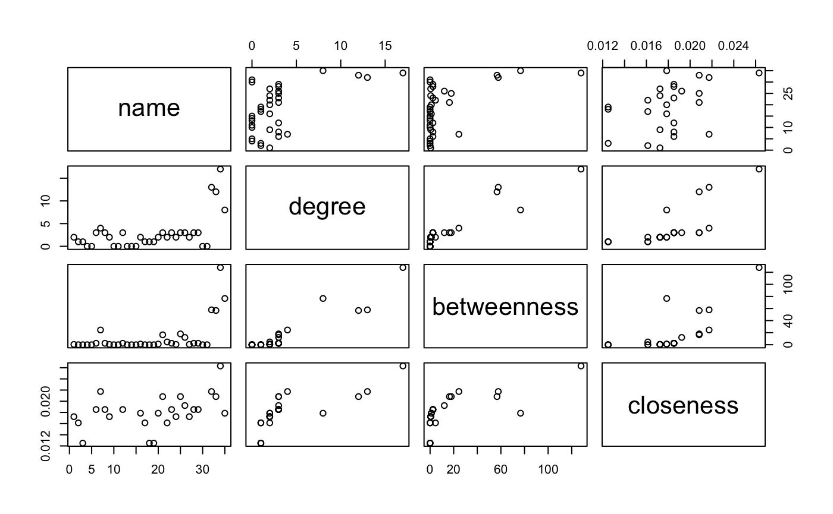

**Figure 6**

From Figure 6, we find that households 4 and 15, with high degree centrality, suggest significant direct connections, indicating their active or influential status in immediate interactions. Notably, nodes 15 and 31 show elevated betweenness centrality, positioning them as crucial bridges that control information flow within the network, potentially acting as gatekeepers. Additionally, their high closeness centrality suggests these nodes can efficiently communicate across the entire network, due to their shorter paths to all other nodes. The aggregation of centrality measures for the groups—such as religious, caste, public meeting, and self-help—further indicates pivotal roles in network connectivity and influence, with the religious group notably standing out due to its substantial betweenness centrality.

Bipartite graph and adjacency matrices

We then created a bipartition matrix and then individual household-by-household and institution by institution matrices.

Each entry in the household-by-household represents the number of shared memberships by both households. The tie indicates the number of institutions both households are members of whereas an absence of a tie means that the households are not members of any of the same institutions. From the matrix, we observe varying levels of connectivity between households. For example, 1 and 2 share memberships in two institutions, as indicated by the value '2' at positions (1,2) and (2,1) in the matrix. This kind of connectivity suggests a form of social cohesion or potential community structures within the village, where households might influence each other through shared participations. The values in the matrix also highlight the density and clusters within the network. For instance, a sequence of higher numbers (like households 2 and 3 sharing three institutions) suggests tighter clusters of households with more robust mutual connections, possibly indicating a strong social, cultural, or economic affinity. Conversely, rows and columns filled predominantly with zeros (like households 8 and 9) indicate isolated households with few or no shared connections to other households through institutional memberships.

On the other hand, the institution by institution graph reflects the interconnections between different types of institutions based on shared memberships from households. This matrix provides insights into how different institutional types are related in terms of their community engagement and collaboration. Notably, there is a substantial overlap between religious and caste groups, with 12 shared memberships, highlighting a significant intersection of cultural identity and community affiliation. This suggests that religious settings may serve dual roles, fostering both spiritual and caste-based communal interactions. Similarly, the connection between religious groups and pubmeet groups, with 10 shared memberships, indicates that religious institutions likely serve as pivotal venues for civic engagement and public discourse. Furthermore, although self-help groups exhibit less connectivity with other groups (3 shared memberships with both religious and caste groups, and 4 with pubmeet groups), they remain integral to the community's support structure, catering to more specialized needs that may not be met by the broader religious or caste-focused groups. This distinct yet connected role underscores the potential for targeted interventions that leverage these unique community ties.

Network Community Structure

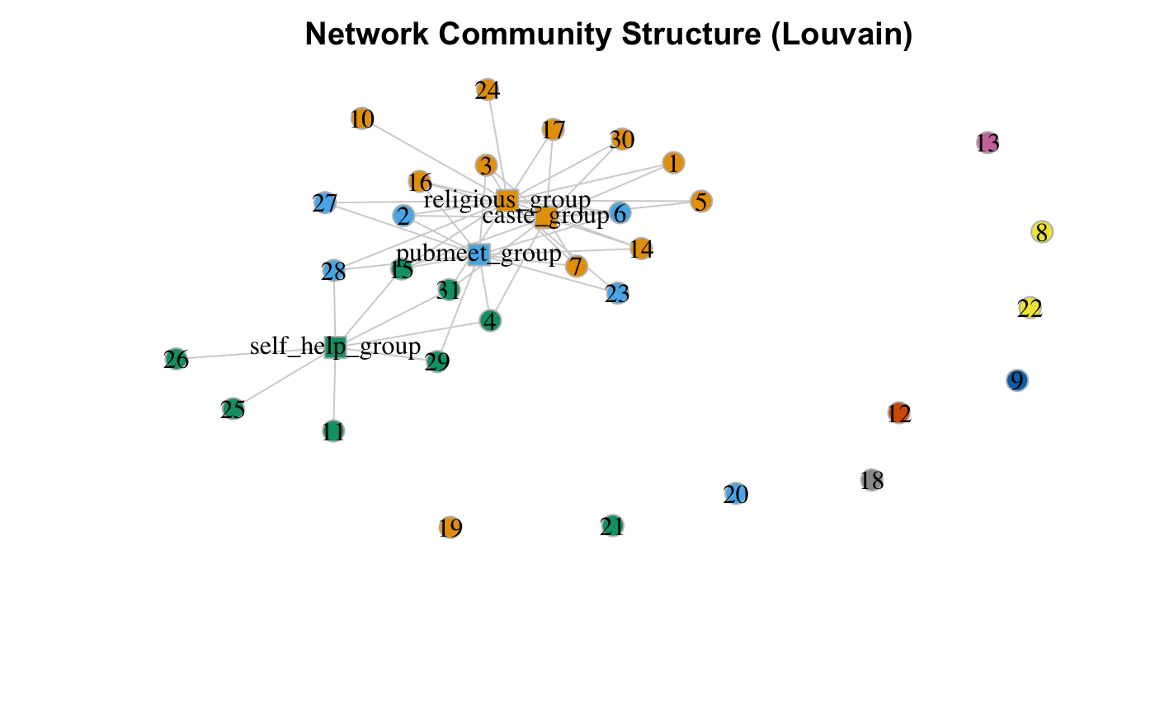

**Figure 7**

In Figure 7, the "Network Community Structure (Louvain)" graph provides a clear depiction of how various institutional groups within a community are interconnected, emphasizing the central role certain groups play in bridging others. Specifically, it reveals that religious and caste groups serve as central nodes, indicating their significant role in fostering community ties and potentially facilitating information and resource flow among members. The self-help groups, while more peripherally connected, are still crucial as they link with central groups, suggesting their role in accessing broader community resources despite their less central position. The distribution and clustering of these groups illustrate not only the direct connections but also the influence these connections may have on community cohesion.

The effect of caste and religion

Next, we calculated institutional memberships, which were the number of connections or affiliations that each household maintains with various institutions within the community, such as schools, clubs, religious groups, and civic organizations. These memberships are crucial for analyzing social integration and access to community resources, which often correlate with socio-economic benefits such as support networks, information flow, and opportunities for civic participation.

We then analyzed the effect of caste and religion on institutional membership as shown in the figure below.

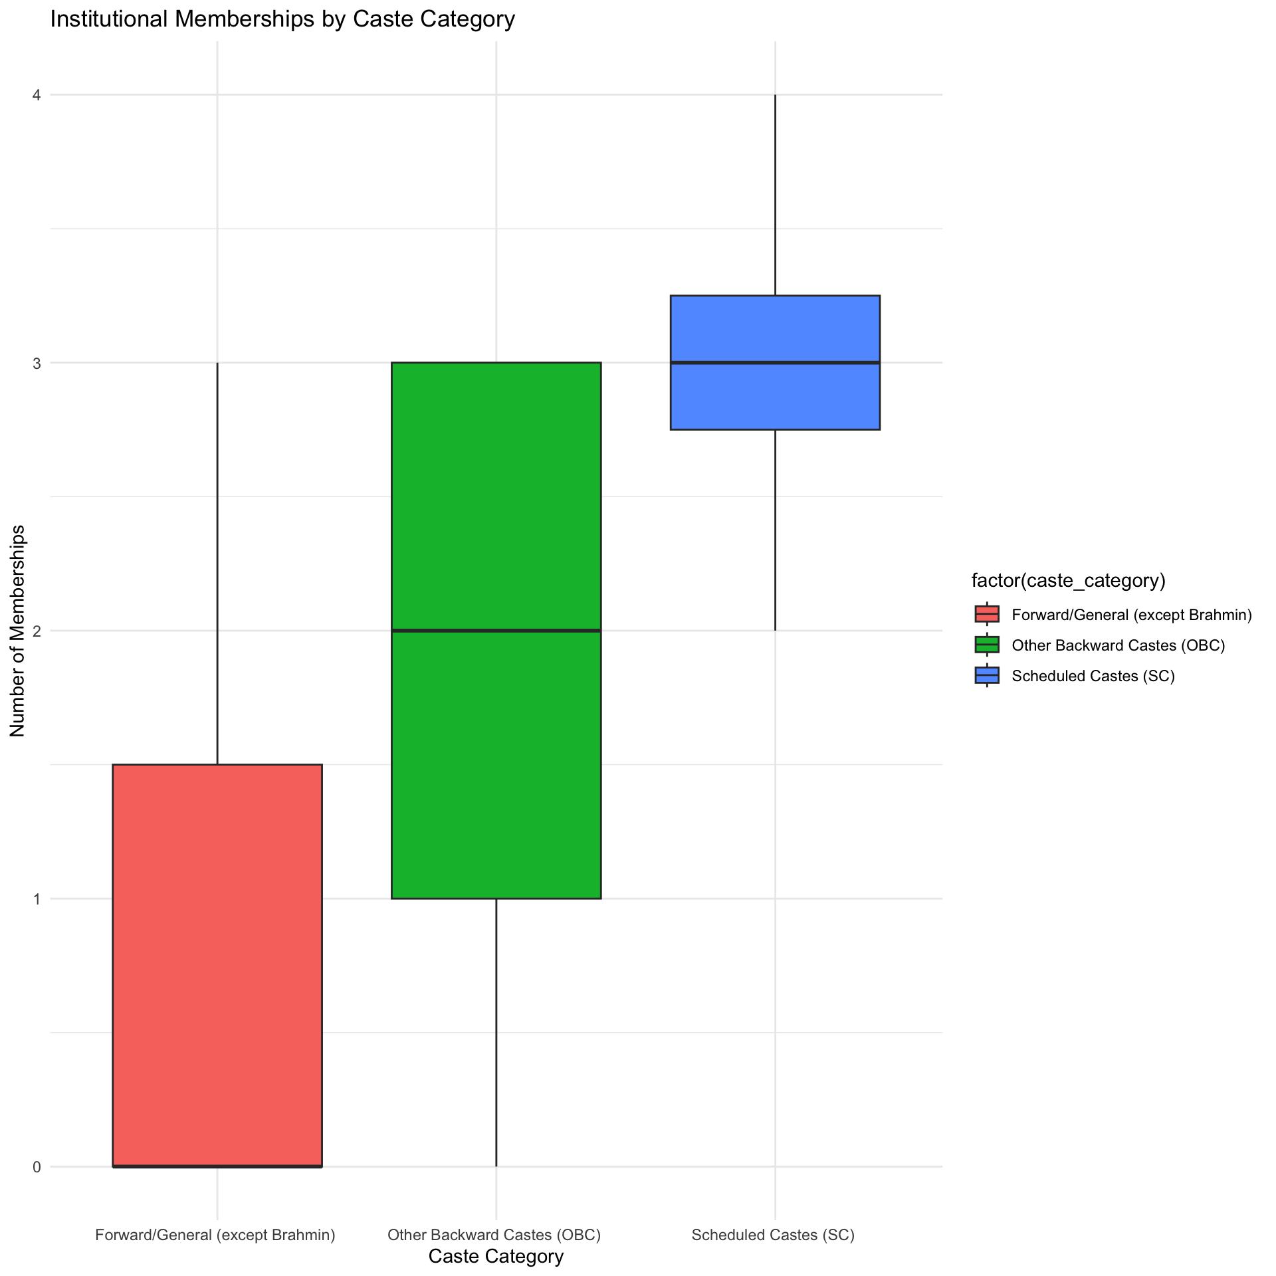

**Figure 8**

Figure 8 reveals significant variance in the number of institutional memberships among different caste categories, illustrating potential patterns of social integration or exclusion within the community. Forward/General (except Brahmin) households are shown to have a lower range and median of institutional memberships, indicating possible under-representation or lesser engagement in community institutions. In contrast, Other Backward Castes (OBC) households exhibit a higher median and a tight interquartile range, suggesting a strong and consistent level of engagement. Scheduled Castes (SC), however, display a broad spectrum of memberships, with some households as engaged as those in the OBC category, while others are much less connected, highlighting variability in their levels of community integration.

We also looked at the effect of religion as shown below in Figure 9. Notably, the Hindu group exhibits a notably higher range of memberships, highlighted by a taller green bar, which indicates both a higher median membership and greater variability compared to the other groups. The Buddhist group is not represented in the data, suggesting either an absence or a non-recordable level of institutional memberships for this group. In contrast, the Muslim group shows fewer memberships with less variability, suggesting a more uniform level of engagement within institutions.

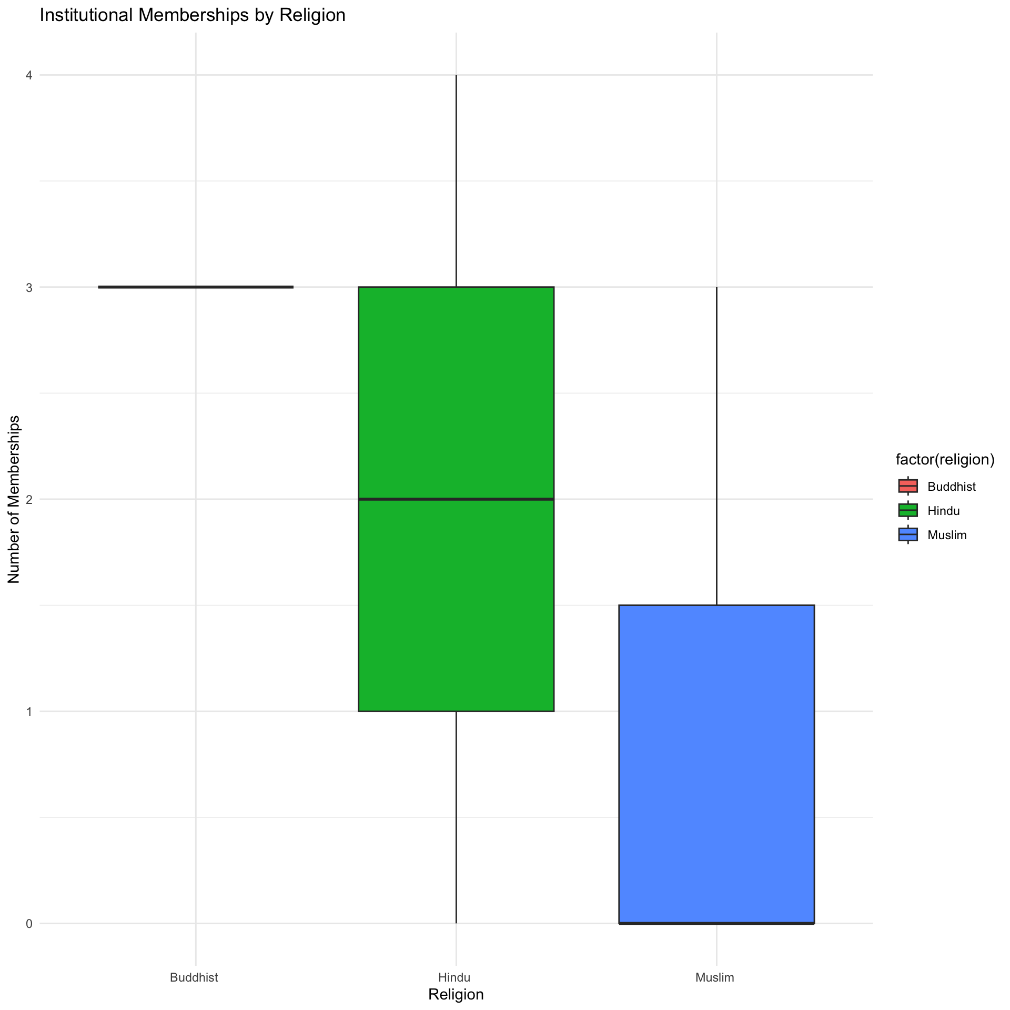

**Figure 9**

Analyze Centrality by Caste and Religion

Given these findings, we decided to better understand the effect of caste and religion on centrality as well. The two box plots below illustrate the degree centrality distributions across different caste categories and religious groups within a network. For caste categories, the plot shows that Other Backward Castes (OBC) and Scheduled Castes (SC) exhibit higher and more varied degrees of centrality compared to Forward/General castes, with OBC having the highest median centrality, indicating stronger or more numerous connections within the network. In terms of religious groups, Hindus display a higher and more variable degree centrality compared to Muslims, suggesting Hindus are more centrally integrated or active within the network's structure. These plots highlight significant differences in network integration and influence across different social groups, reflecting the diverse roles and connectivity that different communities maintain within the network.

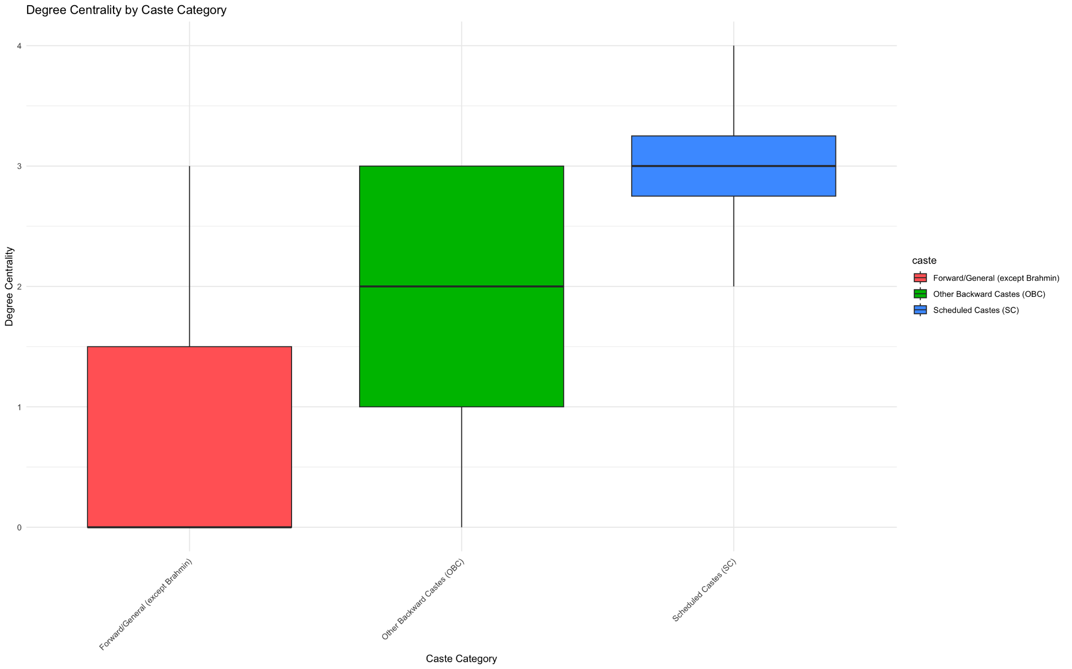

**Figure 10**

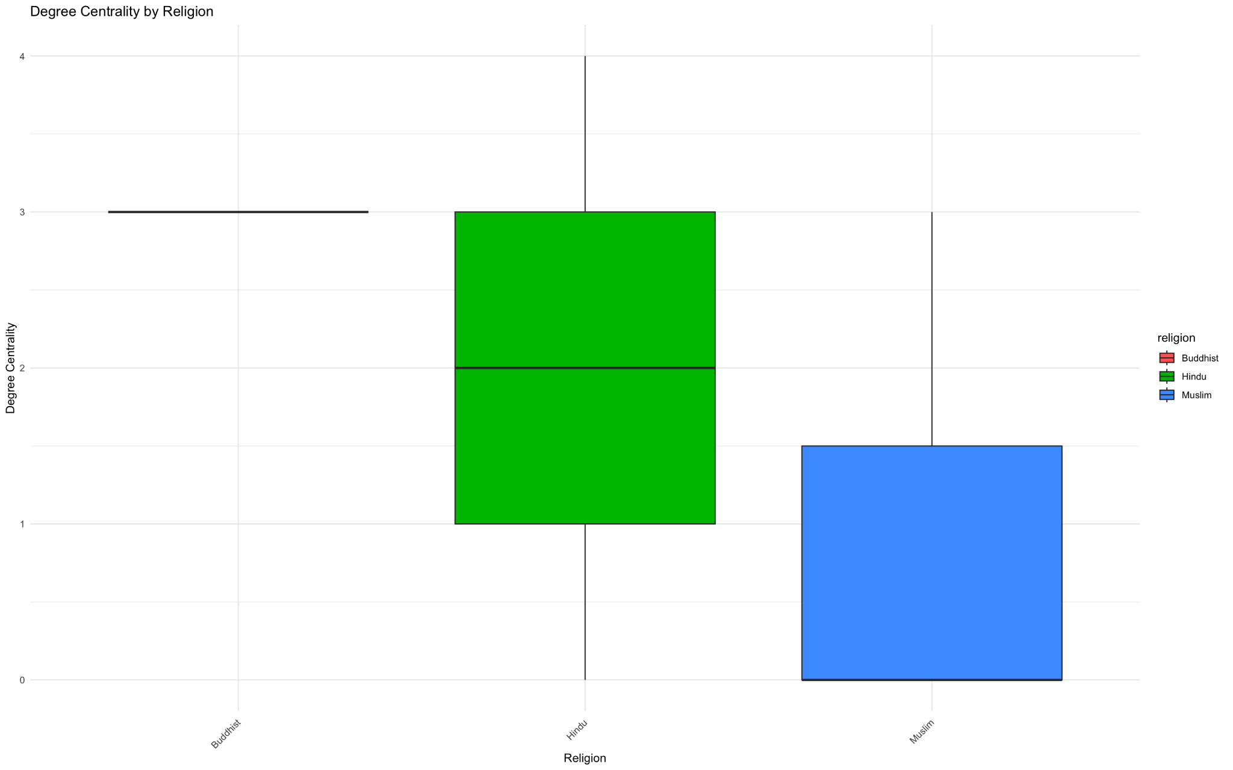

**Figure 11**

For betweenness and closeness, we find that the betweenness centrality data reveals that Scheduled Castes (SC) exhibit a higher median and broader range in their capability to act as brokers within the network, potentially controlling information and resources flow, compared to Other Backward Castes (OBC) and Forward/General categories. This is in stark contrast to the general influence of OBCs who dominate degree centrality, possibly due to the number of households in each caste. In contrast, the closeness centrality shows that Muslims have a wider range of access within the network, indicating that they are on average closer to all other nodes in the network, compared to Hindus and Buddhists who exhibit less variation and lower closeness centrality.

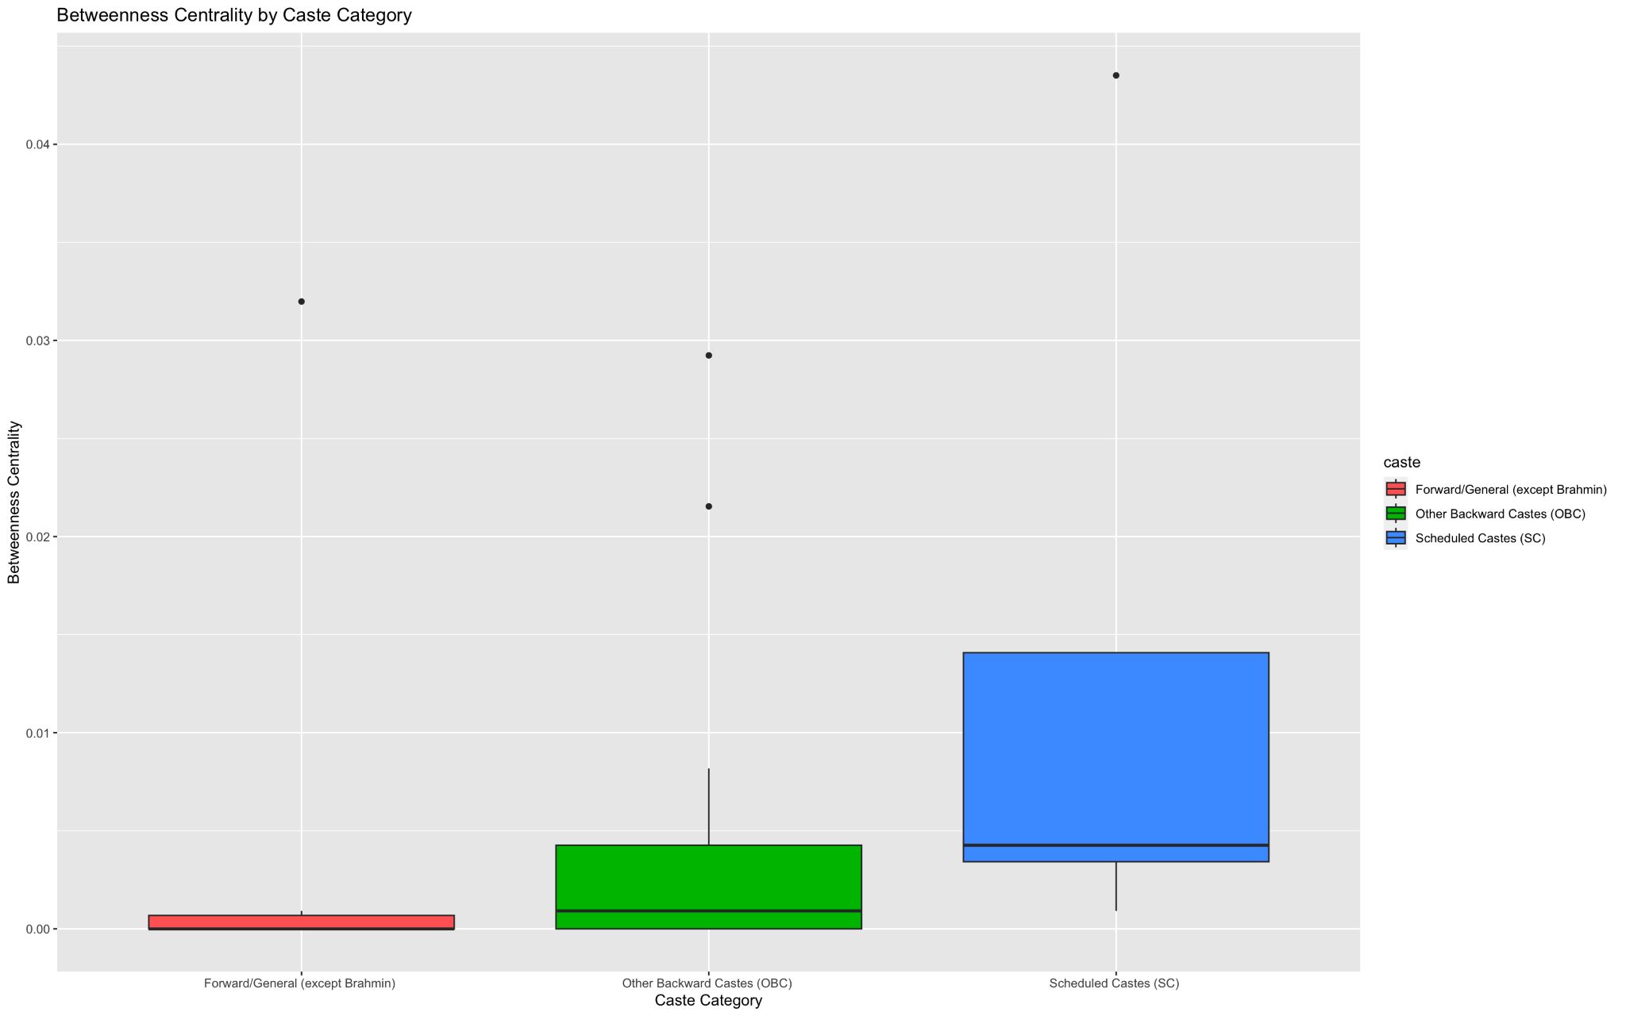

**Figure 12**

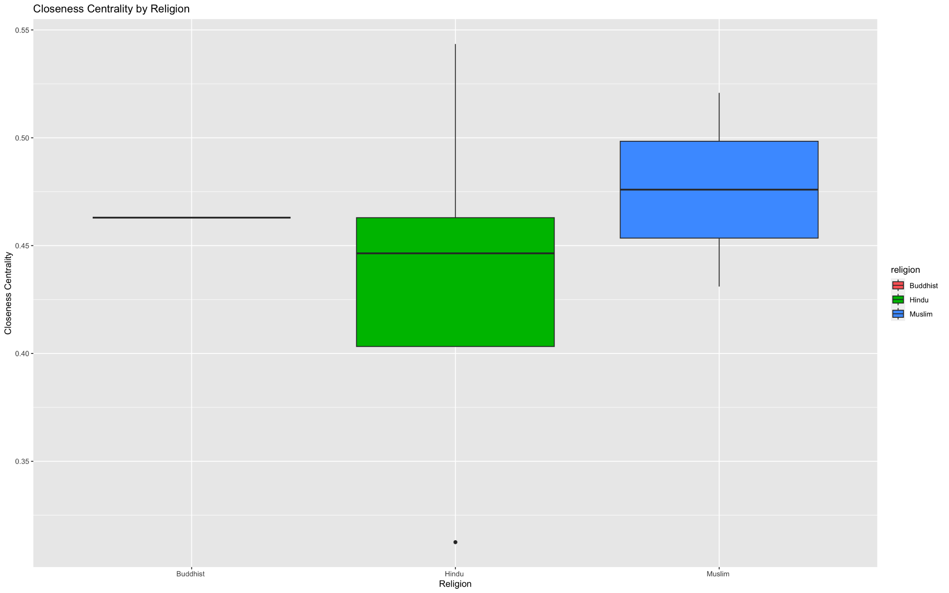

**Figure 13**

**Kerala Village**

Descriptive statistics and centrality measures

The Kerala village had 28 nodes (21 households and 7 institutions). Despite the village having 15 institutions of the households that were interviewed, only 7 institutions are present. These included groups on religion, caste, a self-help group (tailored to doing business) and a public meeting group (tailored to governance issues), a political group, a youth group and a separate business group. It also had 55 edges with the largest component size of 28, with all households connected. The density of villages is higher than the Maharashtra village at 14.5%, highlighting more households are members of different institutions.

​​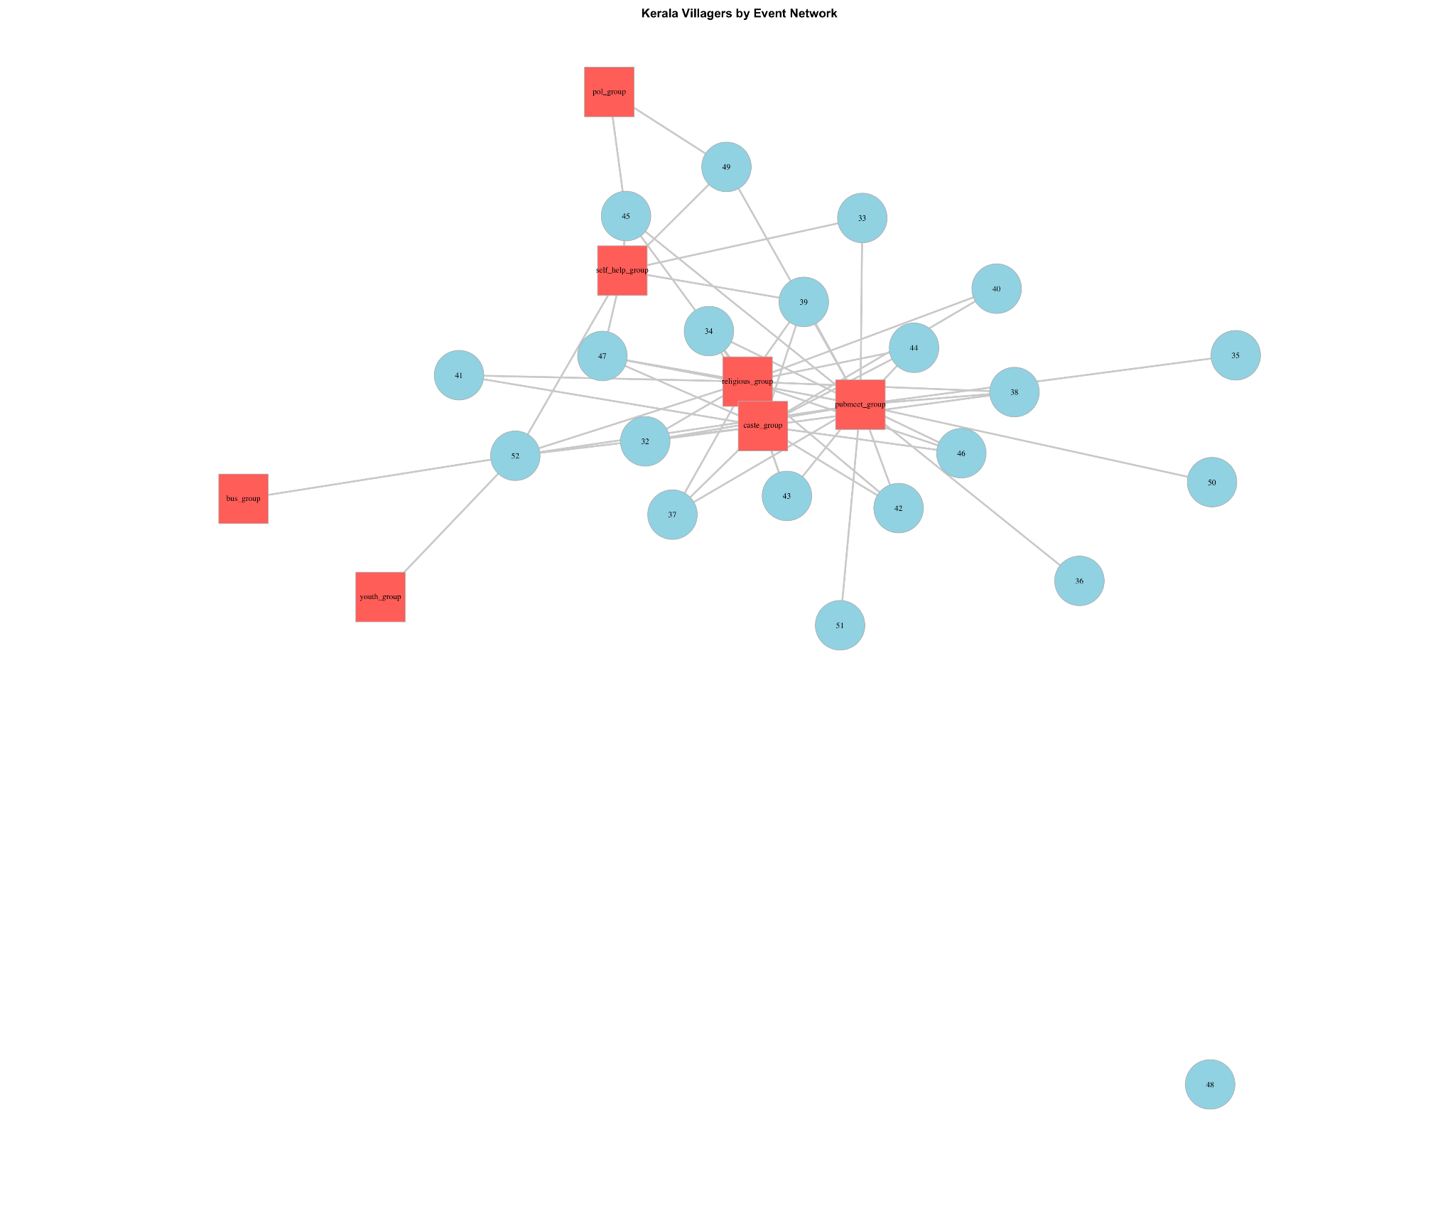

**Figure 14**

We then calculated the various centrality measures, namely degree, betweenness, closeness and eigenvector centrality as showcased below in figure 15

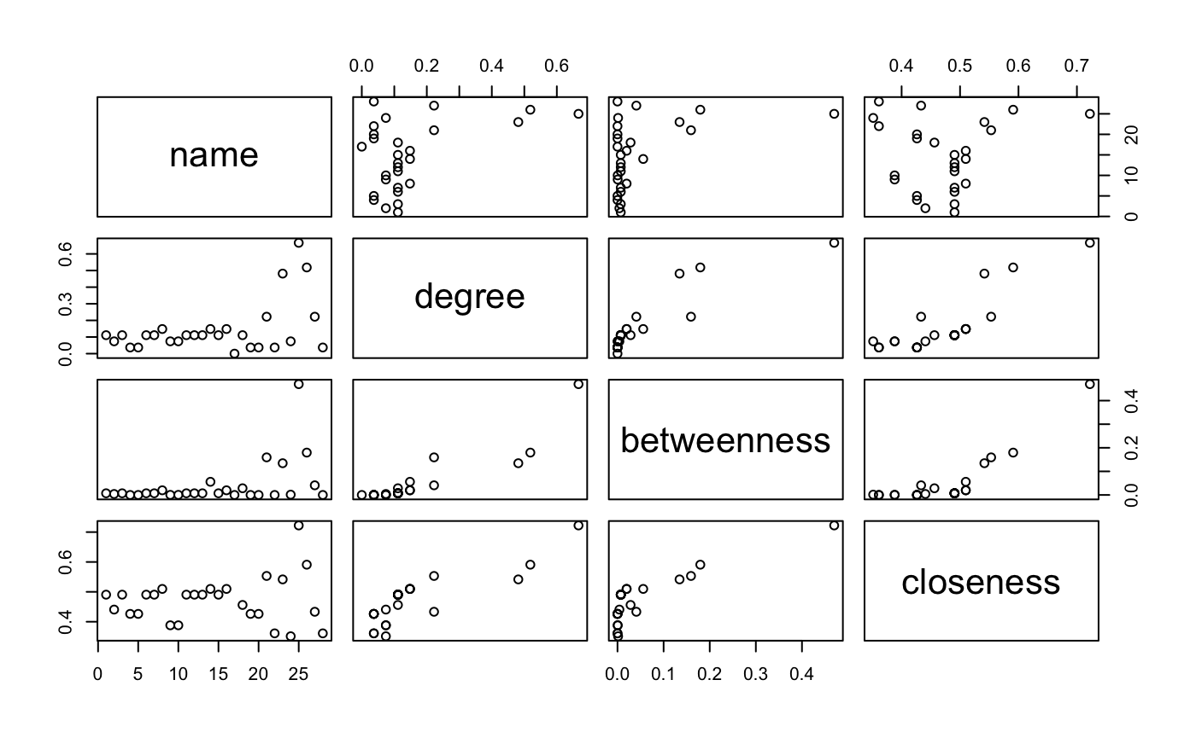

**Figure 15**

Households show varying degrees of connectivity, with most having a moderate degree centrality, reflecting typical engagement levels within the community. Specific households, such as 39 and 45, display notably higher betweenness centrality, indicating their role as critical conduits in the communication and resource flow within the network. Conversely, organized groups exhibit distinct patterns; the public meeting group stands out with the highest measures across all centrality metrics—degree, betweenness, and closeness—suggesting it as a central hub for community interaction and a crucial bridge facilitating connectivity among otherwise disconnected nodes. This group's prominent closeness centrality further emphasizes its accessibility and potential influence within the community. Other groups like the religion group and caste group also demonstrate significant centrality, albeit less than the public meeting group, indicating their important but less central roles.

Bipartite graph and adjacency matrices

We then created a bipartition matrix and then individual household-by-household and institution by institution matrices.

The household by household matrix has values ranging from 0 to 4, indicating the number of institutions that pairs of households share, with higher numbers suggesting a stronger or more multifaceted relationship between specific households. For instance, households like 39 and 47, which register a maximum overlap of 4 shared institutions, suggest these are key nodes within the community, potentially influencing communal activities or resource distributions significantly. Conversely, some households (like 48) show no connections, highlighting their isolation within the social structure of the community.

In the institution by institution matrix, we find that religious and caste groups exhibit the highest degree of overlap, with 13 shared memberships, underscoring the deep-seated integration of cultural and social identities in community activities. The pubmeet group shows substantial connectivity with almost all groups, especially notable are its 12 connections with religious groups and 11 with caste groups, indicating its pivotal role in facilitating public and civic engagement. Self-help groups, while less connected than the pubmeet groups, still show significant ties, particularly with pubmeet groups (6 shared memberships), which may reflect a focus on practical support and community development initiatives. Lesser connected groups like the political, youth, and business groups suggest more specialized or niche roles within the community, highlighting the diverse ways in which different segments of the community interact and support each other.

Network Community Structure

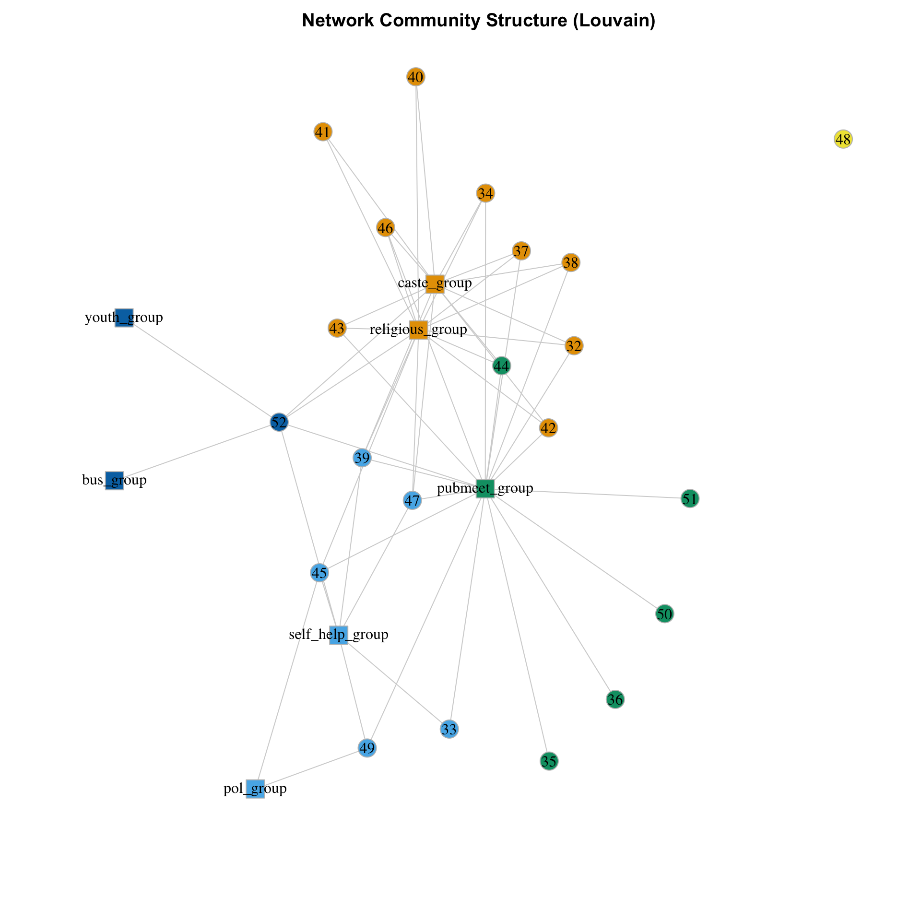

**Figure 16**

Similar to what the matrices told us, we see that in this network, the pubmeet group emerges as a central hub, displaying strong ties to virtually all other groups and numerous households, indicating its vital role in community engagement and coordination. Surrounding this hub, the caste and religious groups also show significant connectivity, not only to each other but across a wide array of households, suggesting their fundamental roles in the social and cultural fabric of the community. Other groups like the youth, business, and political groups, although less central, are still integral, connecting specific nodes that might otherwise be peripheral, thereby facilitating specialized interactions within the community.

The effect of caste and religion

Next, we calculated institutional memberships again, similar to what we did in Maharashtra to understand the effect of caste and religion on it.

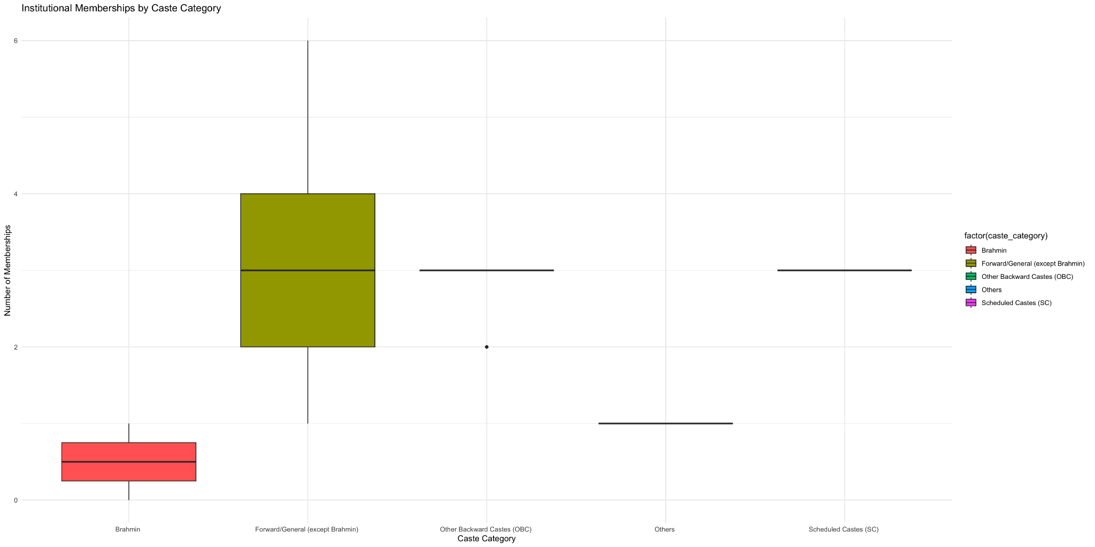

**Figure 17**

The 'Other Backward Castes (OBC)' category demonstrates the highest level of engagement, with membership counts peaking at around four, suggesting a strong and consistent presence in community institutions. Conversely, the 'Brahmin' category shows a surprisingly lower level of engagement, with memberships not exceeding two, indicating lesser participation or integration within institutional networks. The 'Forward/General (except Brahmin)' category also exhibits limited involvement, aligning more with the lower engagement levels of the 'Brahmin' group than the more active OBC category. Notably, categories labeled as 'Others' and 'Scheduled Castes (SC)' show minimal to no institutional memberships, pointing to potential social barriers or exclusion from key community resources.

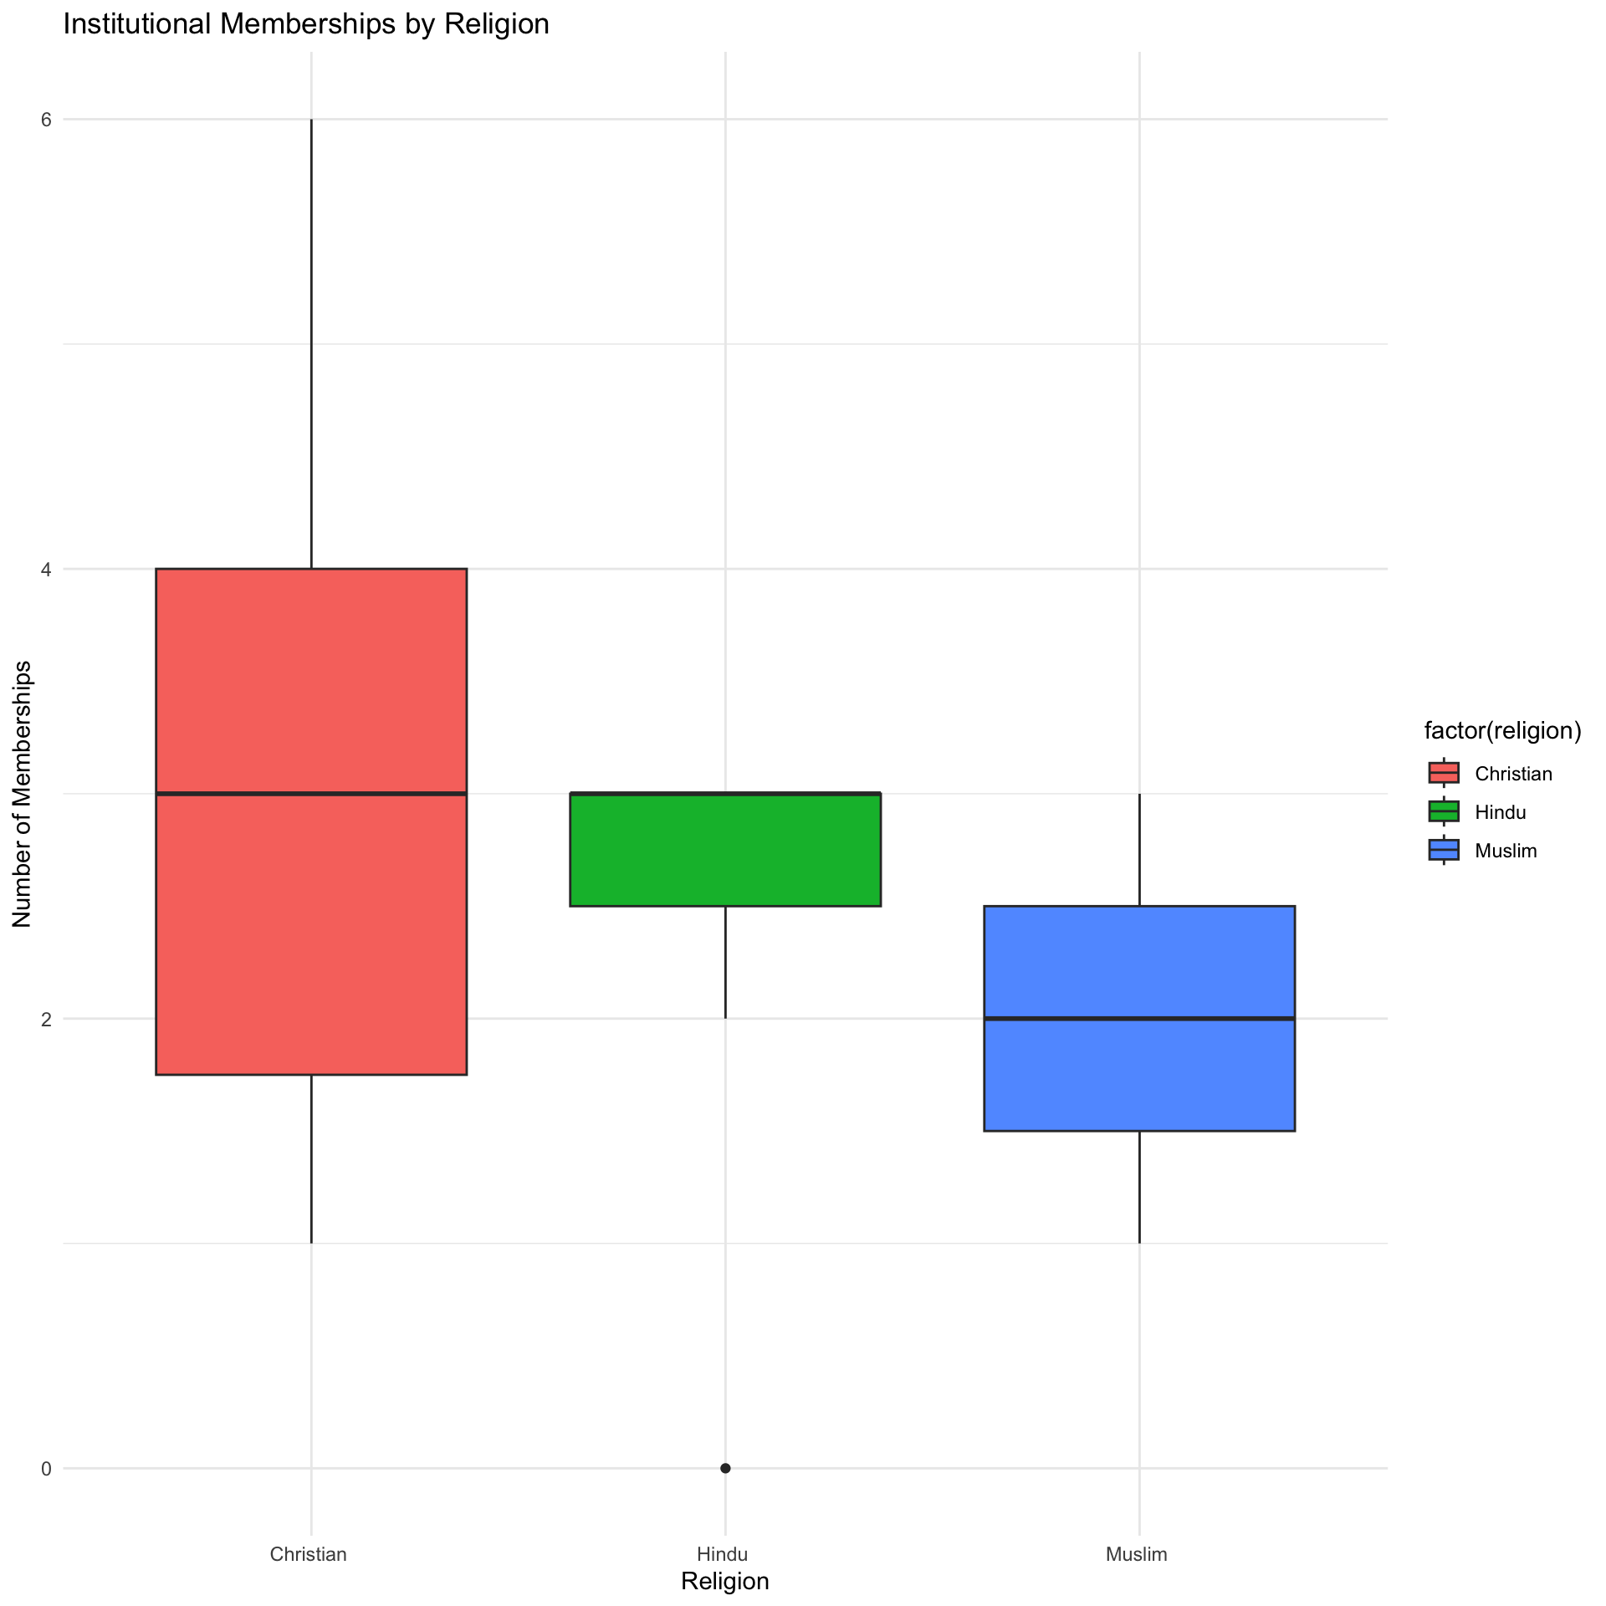

**Figure 18**

Christians display the highest median of institutional memberships, with their involvement ranging significantly, indicating an active participation in various community institutions. Hindus show a moderate level of engagement, with fewer memberships than Christians, but still maintain a consistent presence across institutions. Muslims exhibit a broader range of institutional memberships, though their median involvement is similar to that of Hindus, suggesting varied levels of engagement within their community.

Analyze Centrality by Caste and Religion

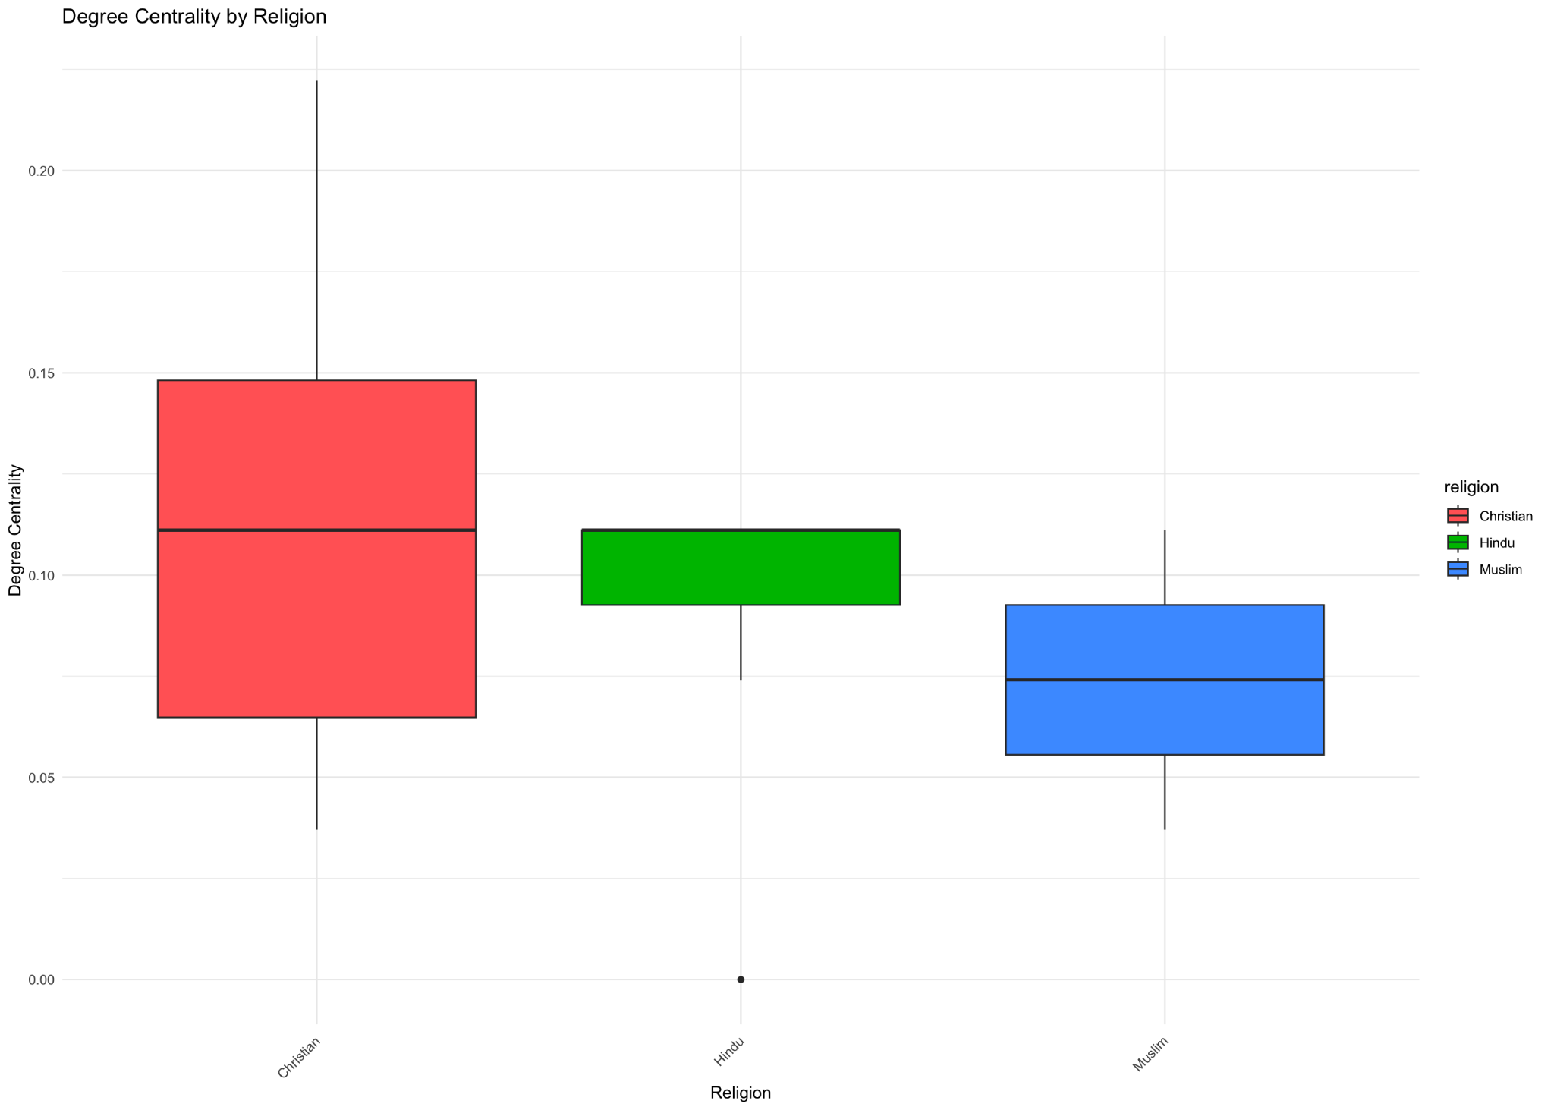

**Figure 19**

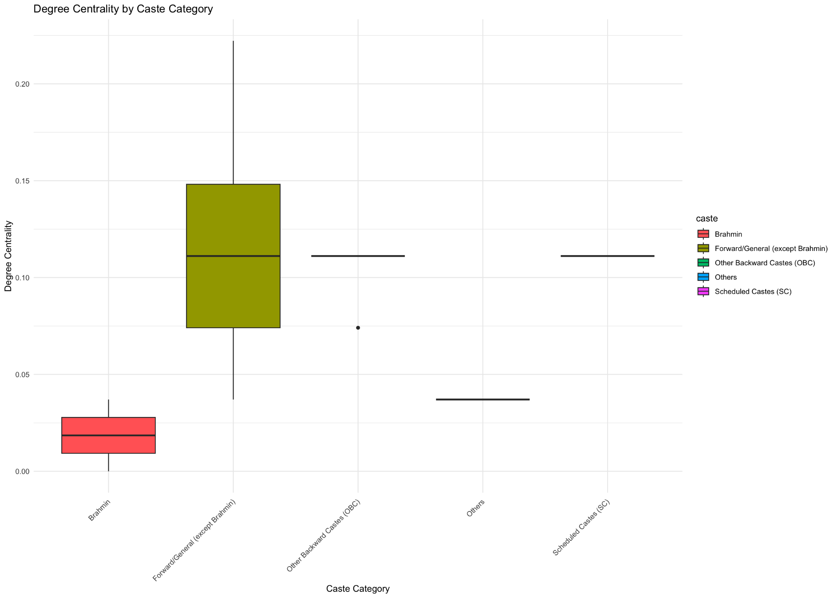

**Figure 20**

The charts on degree centrality above highlight the differing levels of network centrality across various religious and caste groups, shedding light on the social dynamics within the community. In the religious context, Christians exhibit a higher median degree centrality, indicating they are more centrally connected within the network compared to Hindus and Muslims. This could suggest a greater level of communal integration or access to resources among Christians. In contrast, the caste-based chart shows that the 'Other Backward Castes (OBC)' have the highest centrality, suggesting they are pivotal in community interactions, whereas 'Brahmins' and 'Scheduled Castes (SC)' display significantly lower centrality, highlighting potential disparities in social connectivity and influence.

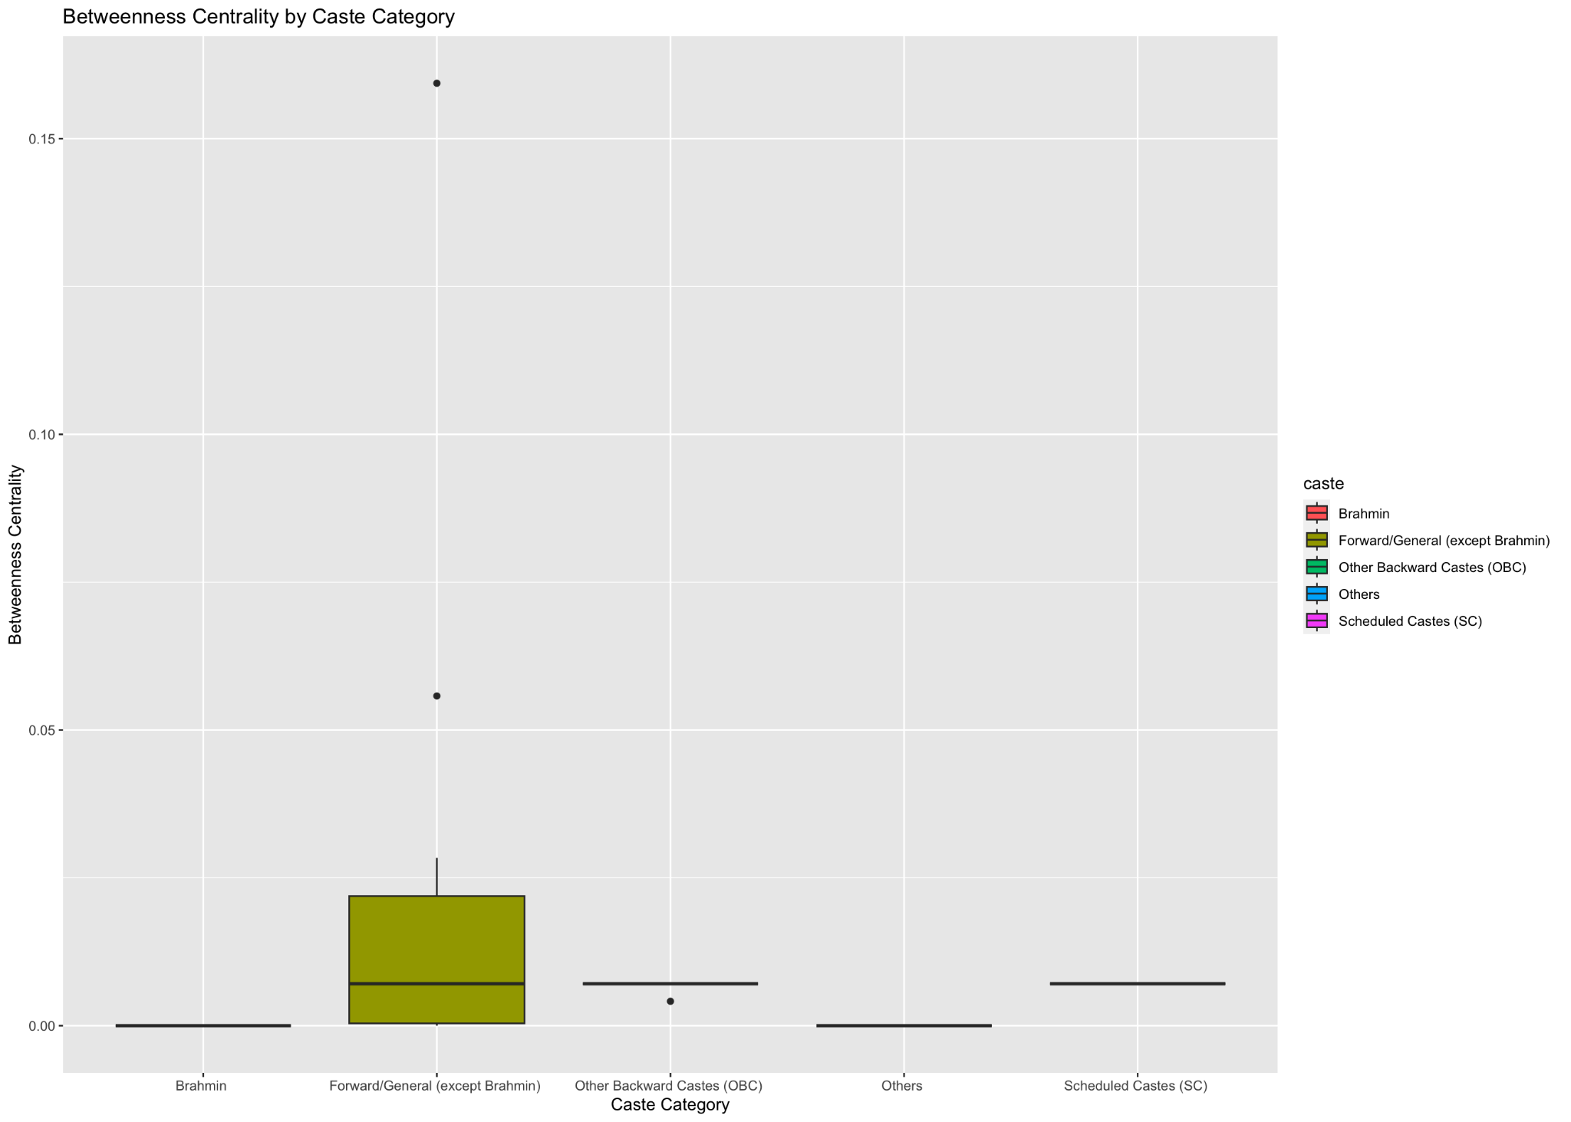

**Figure 21**

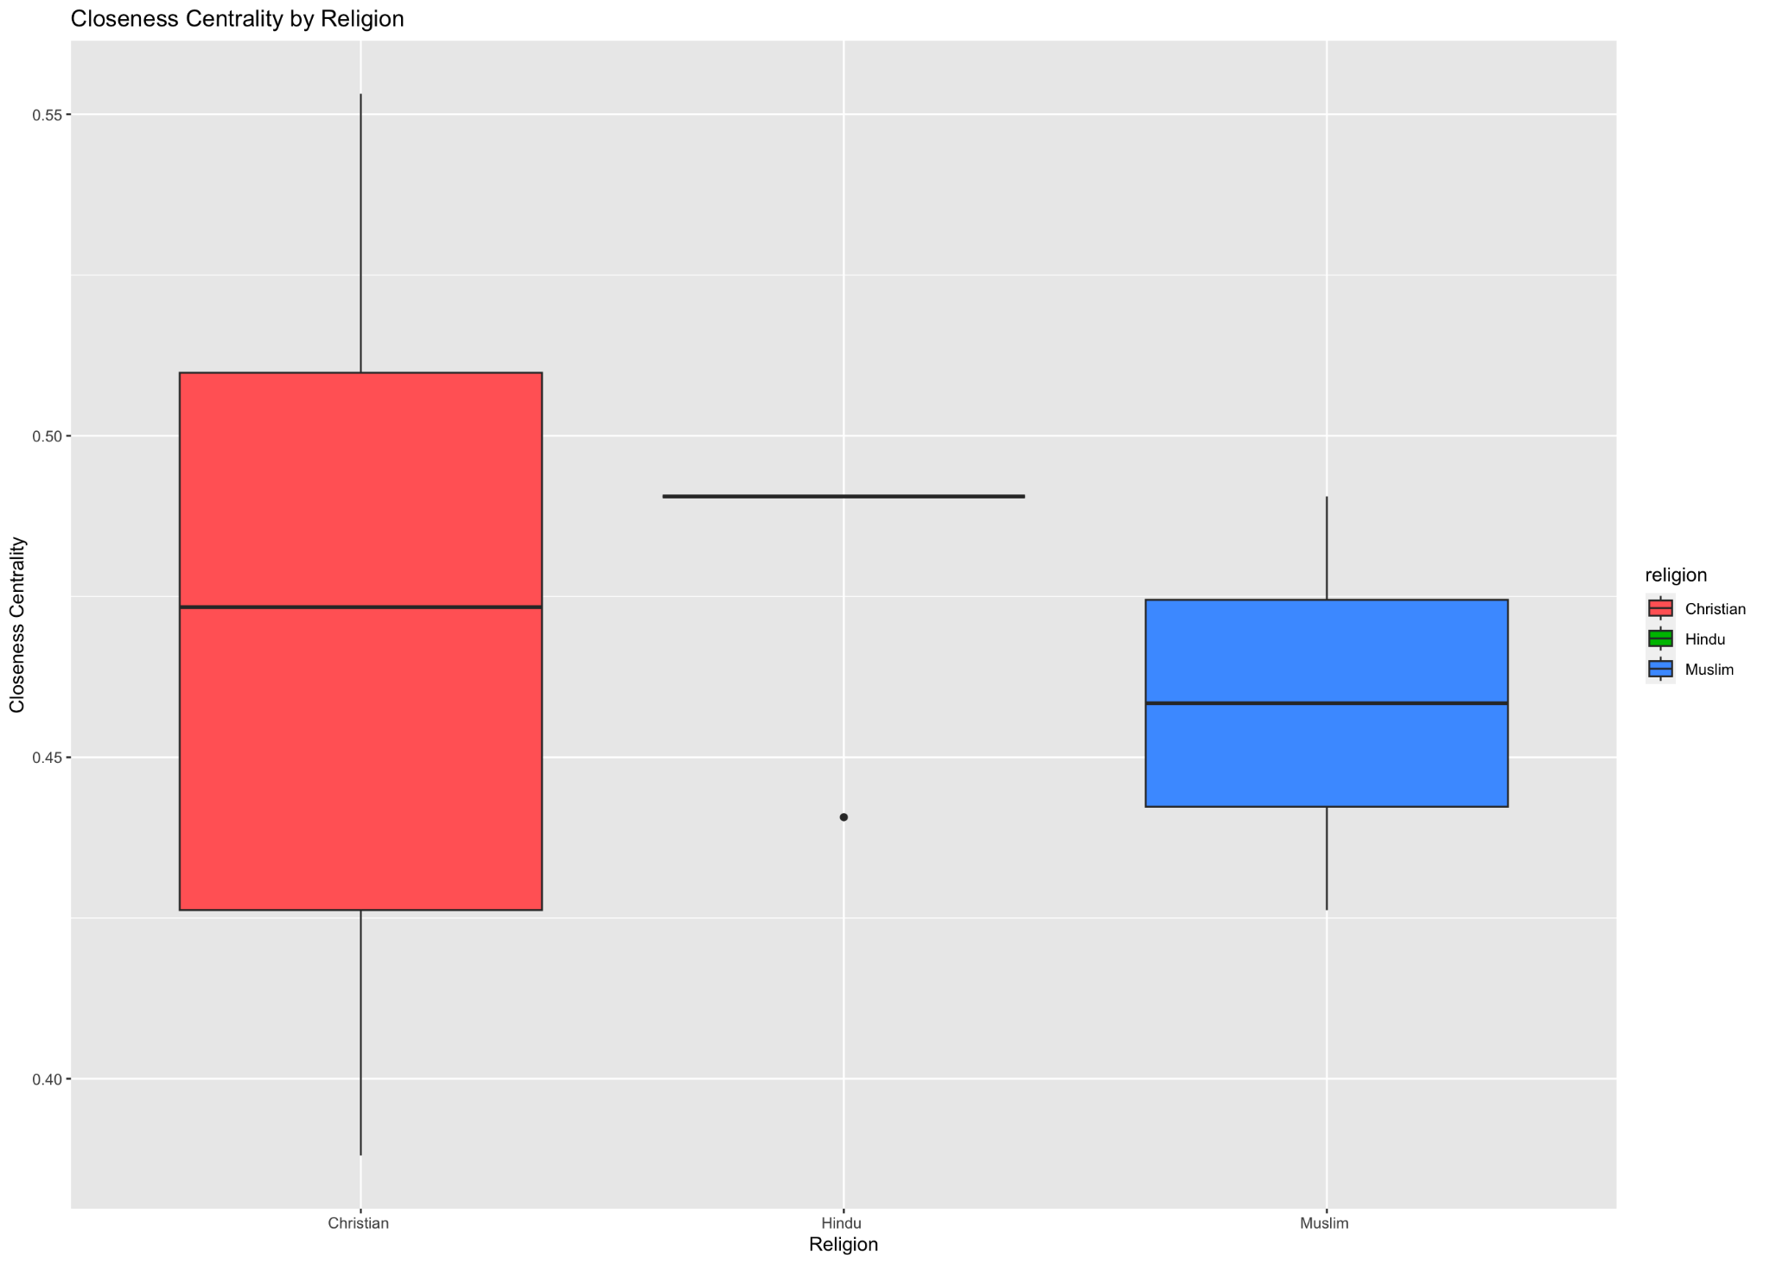

**Figure 22**

The betweenness centrality shown in Figure 22 that the 'Other Backward Castes (OBC)' significantly surpass other caste categories in their potential to control communication flows within the network, indicative of their bridging role between various community segments. In contrast, both 'Brahmins' and 'Scheduled Castes (SC)' exhibit relatively lower betweenness centrality, suggesting less influence over the network's information flow. The closeness centrality for religious groups reveals that Christians are, on average, the closest to all other nodes in the network, possibly reflecting a higher level of integration or accessibility within the community. Meanwhile, Hindus and Muslims exhibit a narrower range of closeness, indicating less uniformity in their network positions.

Comparison between villages

The differences between the two villages in Maharashtra and Kerala provides a nuanced understanding of the role of caste, religion, and community institutions, particularly public meeting groups, play in shaping political participation and social cohesion. In both villages, caste and religion significantly impact the structure and dynamics of social networks, influencing how individuals and households interact with community institutions.

In Maharashtra, the analysis reveals a network characterized by lower density and fewer active institutions, indicating limited community engagement. Notably, the centrality measures suggest a few key households, particularly those belonging to OBC and forward caste categories, hold substantial influence over the flow of information and resources within the village. This indicates a potential concentration of power and resources that might marginalize lower caste and minority religious groups, as these groups showed less centrality and fewer institutional memberships.

Conversely, Kerala presents a more interconnected and denser network, suggesting a higher level of community integration and engagement. The public meeting group in Kerala stands out as a central institution, indicative of its vital role in fostering civic engagement and facilitating a more inclusive dialogue among the community members. This group’s prominence, coupled with a higher overall network density, points to a more effective communal infrastructure that supports a diverse array of interactions across different caste and religious groups, thereby enhancing community participation in governance concerns.

The analysis also highlights the significant role of caste and religion in both villages, with distinct patterns emerging in institutional memberships and centrality measures. In Kerala, the diversity of caste and religion within the network, combined with the active participation in the public meeting group, correlates with a more equitable distribution of community influence and resources. This contrasts with Maharashtra, where specific caste groups exhibit more centrality and control, potentially leading to a less balanced community power structure.

Overall, Kerala appears to be in a better position regarding community engagement and political participation. The effective use of public meeting groups to integrate various social segments, including marginalized castes and religious minorities, suggests a model of community organization that other rural settings might emulate. Enhanced engagement in these groups can potentially mitigate the effects of social stratification and promote more democratic and inclusive community practices.

**Discussion**

Our exploration into the network dynamics of two distinct villages in Maharashtra and Kerala reveals profound insights into the social structure and community engagement influenced by caste and religious affiliations as well as public meeting groups. The overarching research question focused on understanding how these elements affect political participation and civic engagement, using network analysis as the methodology to dissect the community interactions within each village.

In Maharashtra, the network analysis indicated a lower density of connectivity, with only a handful of active institutions that engage with the community. This limited connectivity is reflected in the centrality measures, where only a few nodes (households or institutions) hold significant influence over the flow of information and resources. Such a network configuration suggests a hierarchical or gate kept community structure, where power and resources are concentrated in the hands of a few. This is evident from the leadership which is elected and appointed and predominantly represents the majority population i.e., Hindi and OBC. This shows a clear disconnect for other large groups of Muslims and other castes reflecting in the lower than national average voter participation. Critically, this setup may hinder widespread community engagement and limit opportunities for lower caste and minority religious groups to participate in political and social activities, potentially perpetuating existing inequalities.

Contrastingly, Kerala exhibited a more robust network structure with higher density and more equitable distribution of centrality among its nodes. The active involvement of various social groups, including significant participation from communities like the Christians, who traditionally have a strong presence in Kerala, points towards a more inclusive network. The elected and appointed leader both represent the minority religion of Christianity and minority forward caste which build rooms for diverse representation. In contrast to the Maharashtra village, we hence saw the effect of an inclusive network through a higher than average voter participation rate. The public meeting group in Kerala serves as a central hub that effectively bridges different community segments, enhancing communication and cooperation across diverse groups. This not only facilitates greater community cohesion but also empowers a broader range of individuals to participate in decision-making processes, thereby fostering a more democratic community environment.

The difference in network structures and their implications on community engagement and political participation between the two villages can be largely attributed to how central public meeting groups and other institutions are within each network. In Kerala, where these groups are more central and integrative, there is likely to be higher political participation and more effective civic engagement. In Maharashtra, however, the need for interventions to enhance network connectivity and engagement is evident, suggesting that efforts to strengthen institutions like public meeting groups could lead to significant improvements in community interaction and political participation.

These findings underscore the critical role of social network structures in influencing political participation in rural settings. They highlight the necessity of fostering inclusive and comprehensive network ties, which can significantly impact the social and political fabric of a community. For policymakers and community planners, this suggests that interventions aimed at enhancing network density and inclusivity could be crucial in improving civic engagement and ensuring that all community members have an equal opportunity to participate in governance and community life. This study contributes to the broader discourse on community development and political participation, offering actionable insights that can help guide future efforts towards building more resilient and democratic communities.

**Policy Recommendations**

In a country like India, social values cannot be ignored by policy makers when creating programs for representation. Social values are deep-rooted within us. Their peer group often impacts their decisions. Irrespective of the caste or class, social network, including our friends and relatives, plays an important role in the decision that we take. The result of this paper in this context also shows that direct and indirect social networks are both key in determining how one perceives their democratic duty of participating in politics. It becomes key to reimagine how citizens and governments can interact better especially with the advent of digitization to have inclusive representation.

In line with this analysis, we are planning to introduce a digital platform that better connects these social networks into accessible, centralized, and public dialogues. This involves building an anonymous way to register grievances to facilitate government accountability and provide them with insights into the needs and wants of the citizens. It also means opening up a channel to resolve information asymmetry between citizens and their local government through data and digitization. This approach is based on the hypothesis that a better understanding of local government operations by citizens leads to more informed voting decisions and stronger government accountability. Simultaneously, when local governments gain insights into the welfare needs of their citizens, they can address these issues more effectively. Ultimately, this digital platform aims to strengthen the bond between the Gram Panchayat and grassroots communities, leading to an evidence-based and representative decision-making process.

**References**

Desai, Sonalde, and Reeve Vanneman. India Human Development Survey-II (IHDS-II), 2011-12. ICPSR36151-v6. Ann Arbor, MI: Inter-university Consortium for Political and Social Research [distributor], 2018-08-08. http://doi.org/10.3886/ICPSR36151.v6

Vafaeva, K. M., Ghalwan, M., Surekha, P., Nangia, R., & Bharadwaj, D. (2024). Community Engagement in Smart Cities: A Social Network Analysis and Community Engagement Test. In BIO Web of Conferences (Vol. 86, p. 01073). EDP Sciences.

Johny, J., Wichmann, B., & Swallow, B. M. (2017). Characterizing social networks and their effects on income diversification in rural Kerala, India. World Development, 94, 375-392.

Misra, S., Goswami, R., Basu, D., & Jana, R. (2014). Application of social network analysis in livelihood system study. Space and Culture, India.

Yadav, Y. (2000). Understanding the Second Democratic Upsurge: Trends of Bahujan Participation in Electoral Politics in the 1990s. Transforming India: Social and Political Dynamics of Democracy, 120-145.

Kumar, S. (2017). Caste and Electoral Politics in India. Asian Survey, 57(2), 273-296.

Center for the Study of Developing Societies (CSDS). (2021). Lokniti Research Programme.

Jaffrelot, C. (2003). India's Silent Revolution: The Rise of the Lower Castes in North India. Columbia University Press.

Qutab, Shahana. "Rastriya Swasthya Bima Yojana (RSBY): Analysis of Utilization and Performance in Context of Social Marketing." Issue 1 Int'l JL Mgmt. & Human. 5 (2022): 591.

Chauchard, S. (2018). Why Representation Matters: The Meaning of Ethnic Quotas in Rural India. Cambridge University Press.

Centre for the Study of Developing Societies (CSDS). (2021). Lokniti Research Programme.

Kumar, Neha, Kalyani Raghunathan, Alejandra Arrieta, Amir Jilani, and Shinjini Pandey. "The power of the collective empowers women: Evidence from self-help groups in India." World Development 146 (2021): 105579.

Johny, Judit, Bruno Wichmann, and Brent M. Swallow. "Characterizing social networks and their effects on income diversification in rural Kerala, India." World Development 94 (2017): 375-392.

Hussain, Y. R., & Mukhopadhyay, P. (2023). How Much do Education, Experience, and Social Networks Impact Earnings in India? A Panel Data Analysis Disaggregated by Class, Gender, Caste, and Religion. SAGE Open, 13(4), 21582440231220942.

Bhattacharjee, Deepabali, and Pratap C. Mohanty. "Do information differentials and confidence in medical institutions influence out-of-pocket expenditure on health care in India?" Clinical Epidemiology and Global Health 13 (2022): 100952.

Bardhan, Pranab, and Dilip Mookherjee. "Capture and governance at local and national levels." American economic review 90, no. 2 (2000): 135-139.

Beaman, Lori, Esther Duflo, Rohini Pande, and Petia Topalova. "Political reservation and substantive representation: Evidence from Indian village councils." In India policy forum, vol. 7, no. 1, pp. 159-201. National Council of Applied Economic Research, 2011.

Chattopadhyay, Raghabendra, and Esther Duflo. "Women as policy makers: Evidence from a randomized policy experiment in India." Econometrica 72, no. 5 (2004): 1409-1443.

Panda, Sitakanta. "Political connections and elite capture in a poverty alleviation programme in India." The Journal of Development Studies 51, no. 1 (2015): 50-65.

Alatas, Vivi, Abhijit Banerjee, Rema Hanna, Benjamin A. Olken, Ririn Purnamasari, and Matthew Wai-Poi. "Does elite capture matter? Local elites and targeted welfare programs in Indonesia." In AEA Papers and Proceedings, vol. 109, pp. 334-339. 2014 Broadway, Suite 305, Nashville, TN 37203: American Economic Association, 2019.

Gambhir, Ishita, Sonalde Desai, and Reeve Vanneman. "Role of networks in the elite capture of food subsidy program in India." In International Union for the Scientific Study of Population (IUSSP) XXVIII International Population Conference was held, vol. 29. 2017.

Vafaeva, Khristina Maksudovna, Manish Ghalwan, P. Surekha, Richa Nangia, and Deepak Bharadwaj. "Community Engagement in Smart Cities: A Social Network Analysis and Community Engagement Test." In BIO Web of Conferences, vol. 86, p. 01073. EDP Sciences, 2024.